Setup ARGO CD

Setup Argo CD on Kubernetes / EKS
Argo CD official install creates argocd namespace and installs all components there.
1. Check cluster
kubectl get nodes
Nodes must be Ready.
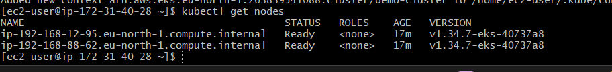
2. Install Argo CD
kubectl create namespace argocd
kubectl apply -n argocd --server-side --force-conflicts \
-f https://raw.githubusercontent.com/argoproj/argo-cd/stable/manifests/install.yaml
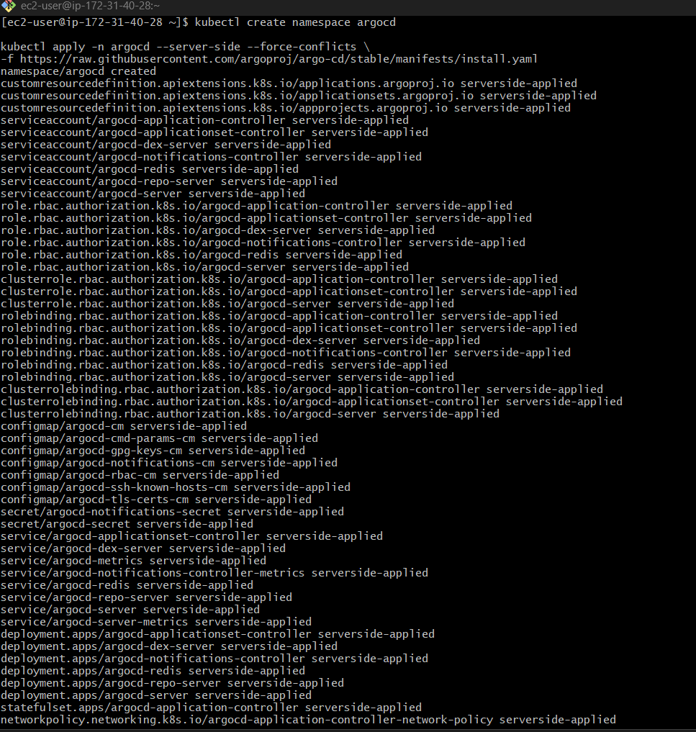
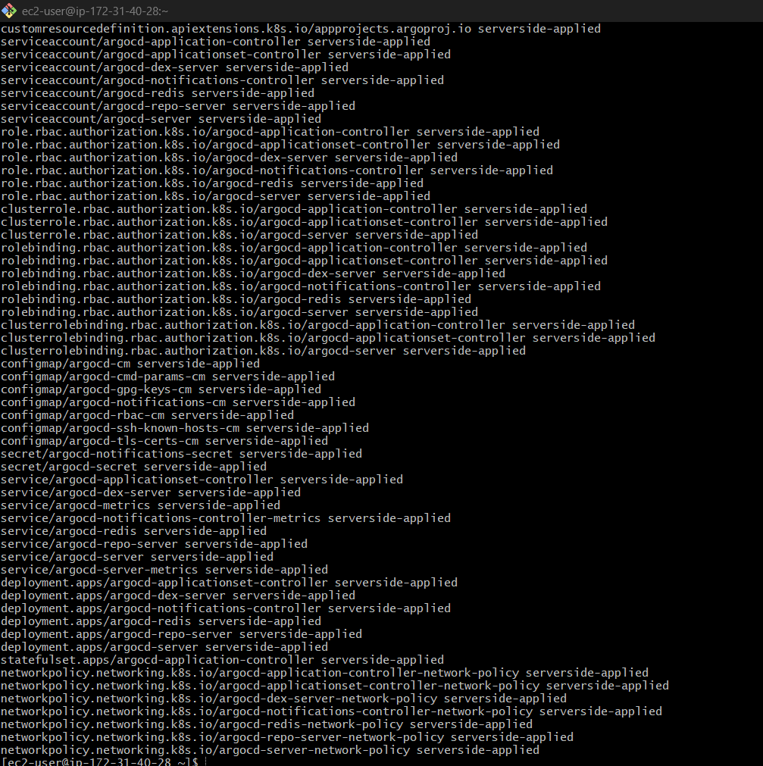
3. Check pods
kubectl get pods -n argocd
Wait until all pods show Running.
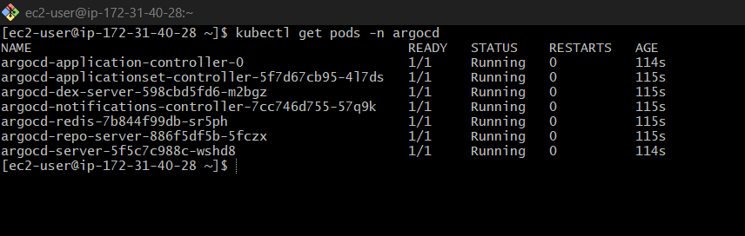

kubectl get svc -n argocd
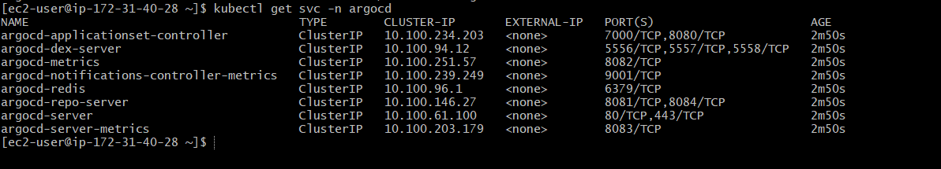
Expose Argo CD UI using LoadBalancer
For EKS:
kubectl patch svc argocd-server -n argocd \
-p '{"spec": {"type": "LoadBalancer"}}'
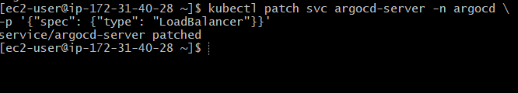
Check URL:
kubectl get svc argocd-server -n argocd
a742141a7854041418eced4bb61eae15-1709993908.eu-north-1.elb.amazonaws.com
Example:
a1b2c3d4.elb.amazonaws.com
Open in browser:
https://EXTERNAL-IP
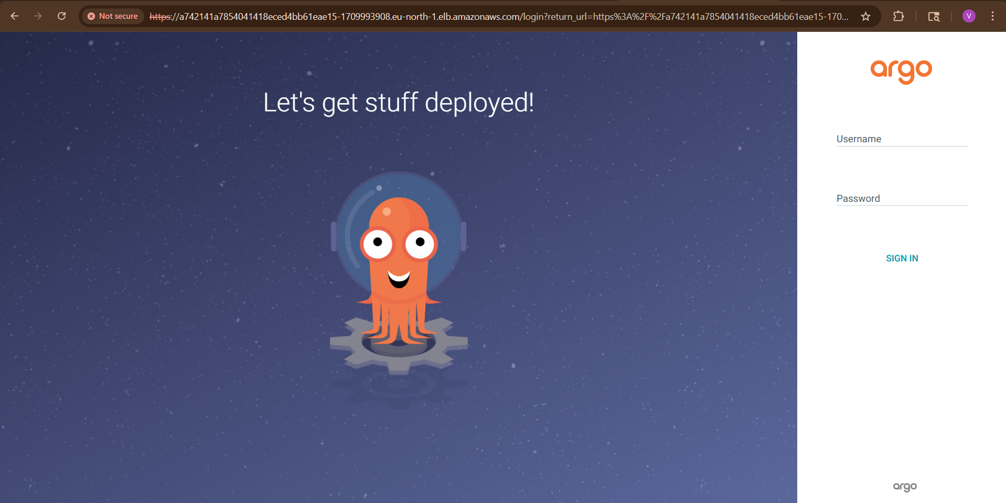
Step 6 — Get Initial Admin Password
Username:
admin
Get password:
kubectl get secret argocd-initial-admin-secret \
-n argocd \
-o jsonpath="{.data.password}" | base64 -d
Copy password.
bdTVEDC0oHQ-HXwd
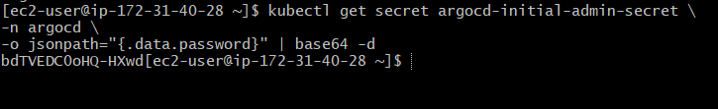
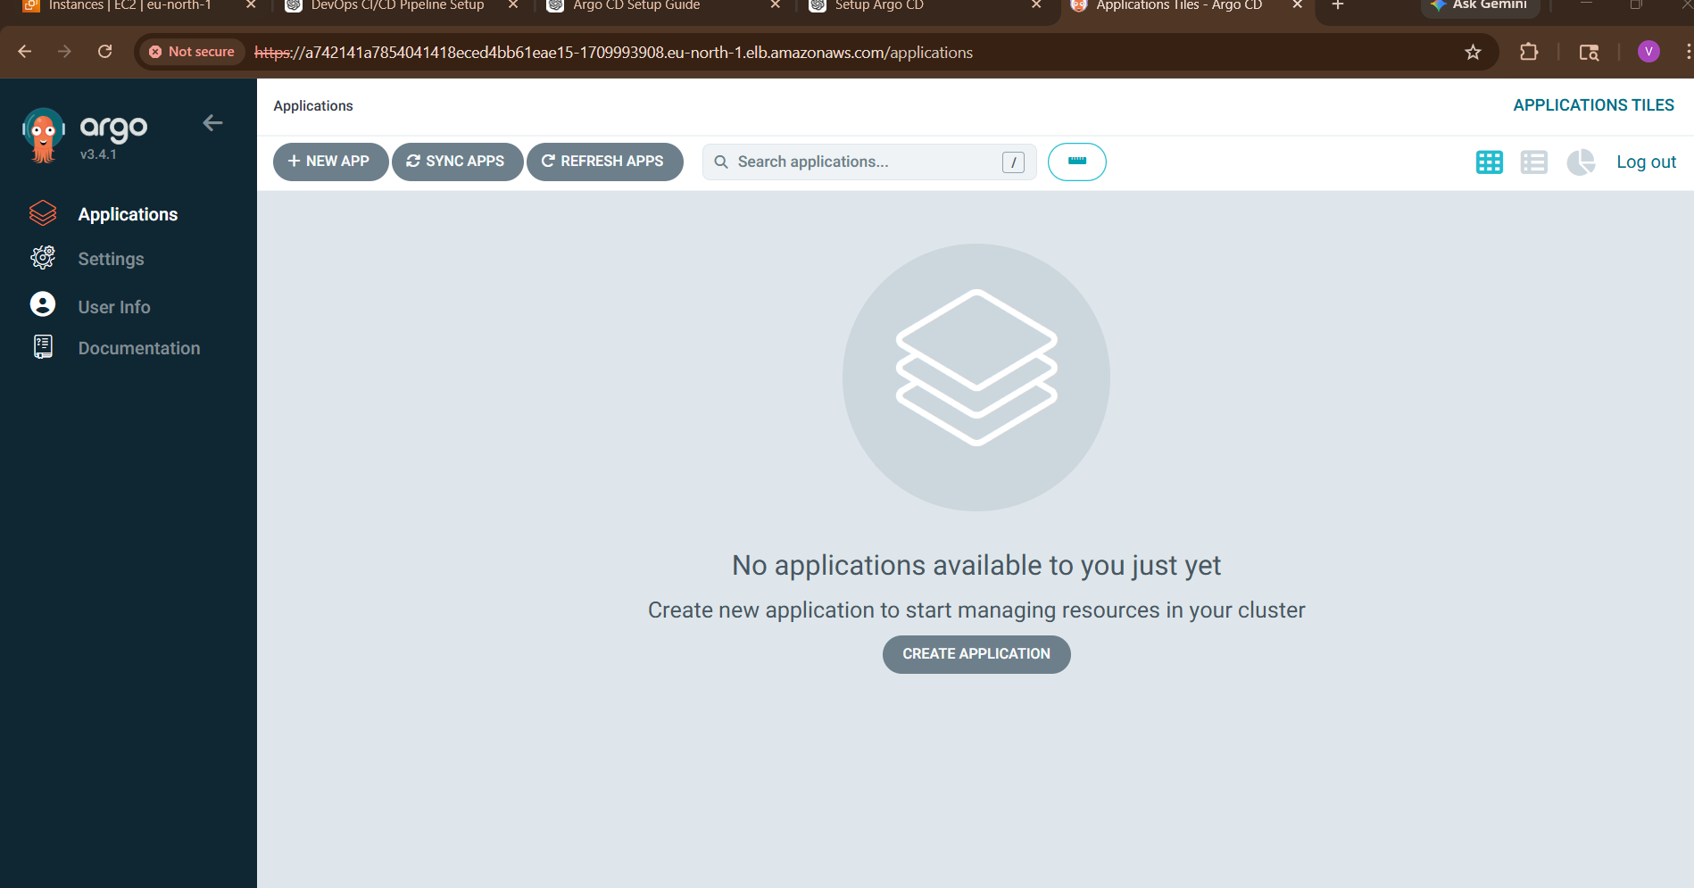
Step 7 — Login to Argo CD UI
Open:
https://<ARGOCD-URL>
https://a742141a7854041418eced4bb61eae15-1709993908.eu-north-1.elb.amazonaws.com/applications
Login:
Username: admin
Password: <copied-password> bdTVEDC0oHQ-HXwd

Create Jenkins job for CI.
Goal of CI Job:
- Pull code from GitHub
- Build application
- Run Maven build
- Generate artifact (.jar/.war)
TEP 1: Open Jenkins
Open:
http://<EC2-PUBLIC-IP>:8080
Login with:
- Username: admin
- Your Jenkins password

STEP 2: Install Required Plugins
Go to:
Manage Jenkins → Plugins
Install these plugins:
Plugin | Purpose
Git | Pull code from GitHub
Pipeline | Pipeline jobs
Docker Pipeline | Docker integration
Maven Integration | Maven builds
After install:
Restart Jenkins

STEP 3: Install Java & Maven Inside Jenkins Container
Enter Jenkins container:
docker exec -u 0 -it jenkins bash
Update packages:
apt update
Install Java + Maven + Git:
apt install -y openjdk-17-jdk maven git
Verify:
java -version
mvn -version
git --version
Exit:
Exit
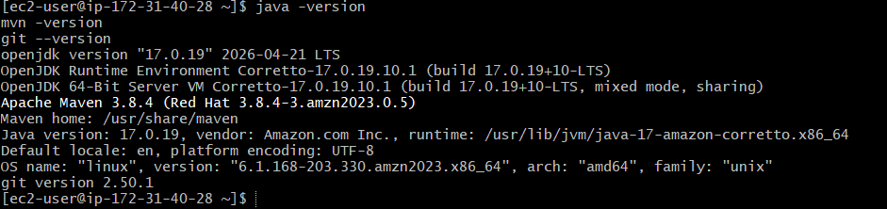

STEP 4: Configure JDK & Maven in Jenkins
Go to:
Manage Jenkins → Tools

Add JDK
JDK Section
Click:
Add JDK
Set:
Field | Value
Name | jdk17
JAVA_HOME | /usr/lib/jvm/java-17-openjdk-amd64
Uncheck:
Install automatically

Add Maven
Maven Section
Click:
Add Maven
Set:
Field | Value
Name | maven3
MAVEN_HOME | /usr/share/maven
Uncheck:
Install automatically
Click:
Save

STEP 5: Create CI Job
Go to Jenkins dashboard.
Click:
New Item
Enter:
my-ng-ci
Select:
Pipeline
Click:
OK

STEP 6: Configure GitHub Repo
Under:
Pipeline → Definition
Choose:
Pipeline script

STEP 7: Add Pipeline Script
Paste this:
pipeline {
agent any
stages {
stage('Git Clone') {
steps {
git branch: 'main',
url: 'https://github.com/betawins/hiring-app.git'
}
}
stage('Maven Build') {
steps {
sh 'mvn clean package'
}
}
stage('Test') {
steps {
sh 'mvn test'
}
}
stage('Archive Artifact') {
steps {
archiveArtifacts artifacts: 'target/*.war', fingerprint: true
}
}
}
}
Click:
Save

STEP 8: Run CI Job
Click:
Build Now

STEP 9: Check Console Output
Click:
Build History → latest build → Console Output
You should see:
BUILD SUCCESS

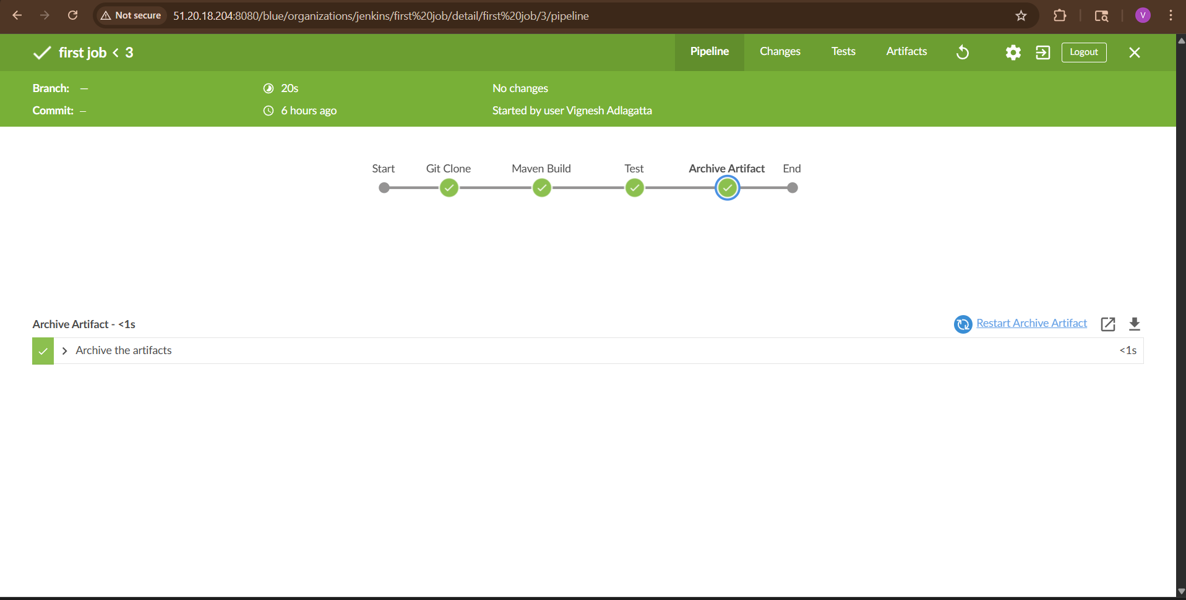
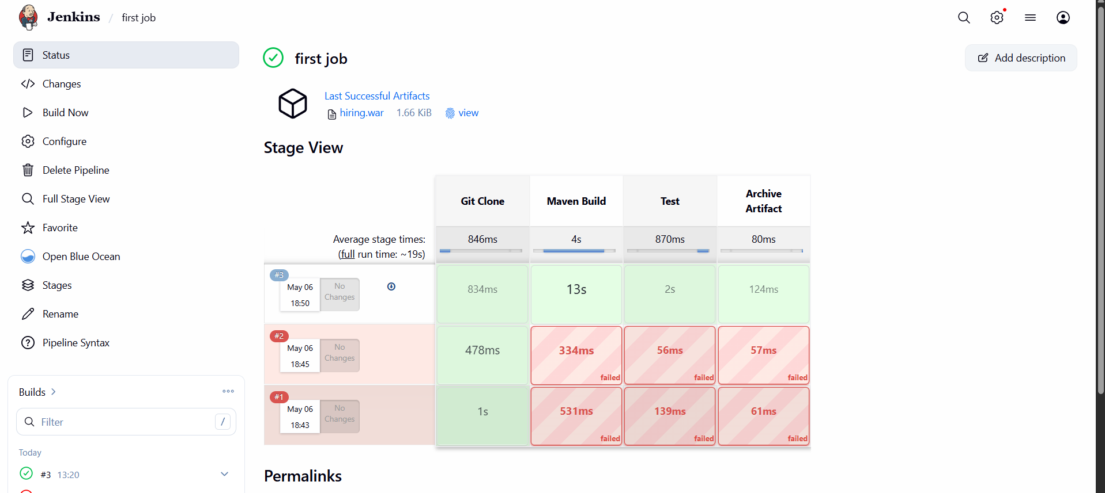
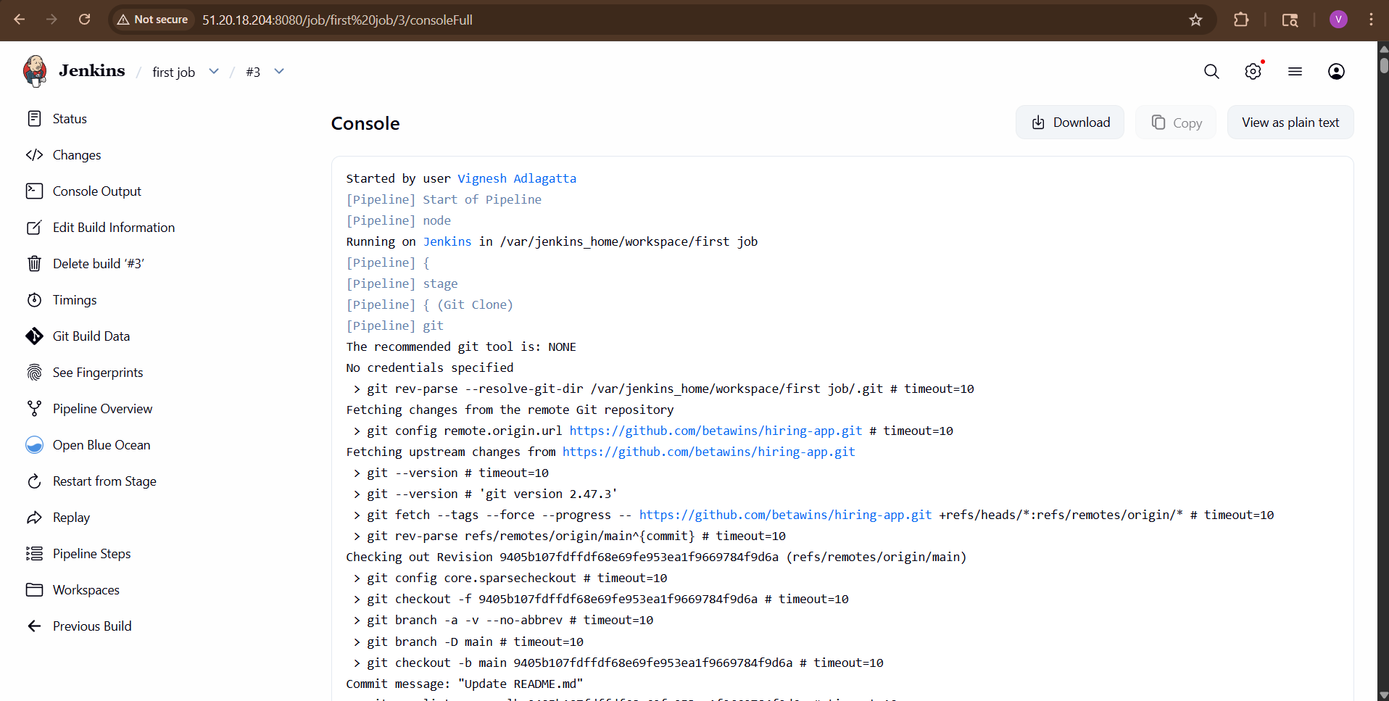
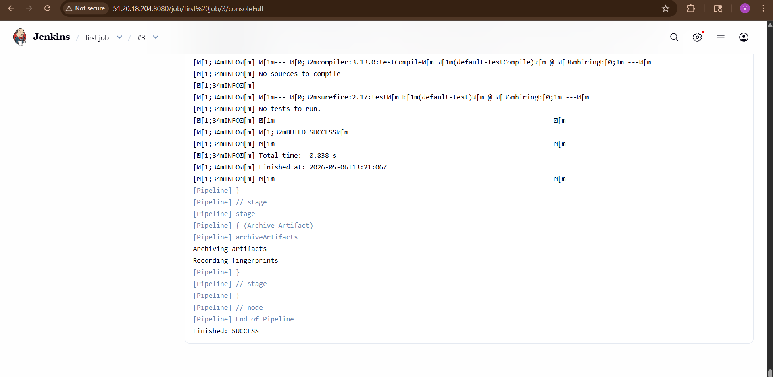

STEP 10: Verify Artifact
Go inside Jenkins container:
docker exec -it jenkins bash
Find build artifact:
find /var/jenkins_home/workspace/ -name "*.jar"
OR
find /var/jenkins_home/workspace/ -name "*.war"

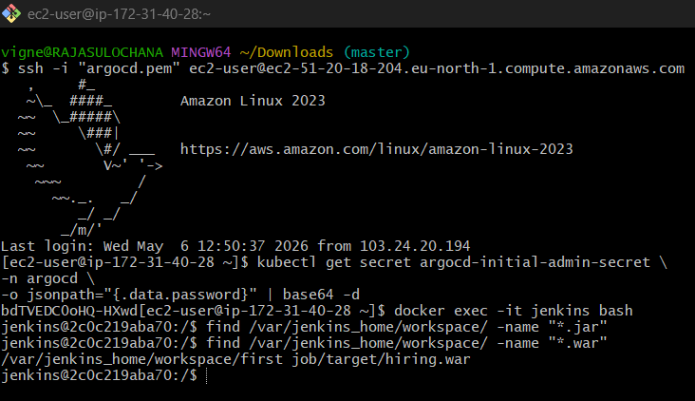

CI Flow Completed
Current flow:
GitHub Repo
↓
Jenkins Pulls Code
↓
Maven Build
↓
Artifact Generated

Create Jenkins job to create docker image and build image.

Architecture Flow
GitHub Repo
↓
Jenkins CI Job
↓
Maven Build
↓
Docker Image Build
↓
Run Container

STEP 1: Verify Docker Running On EC2
Run:
docker ps
If Docker not installed:
sudo yum install docker -y
sudo systemctl start docker
sudo systemctl enable docker
Verify:
docker –version
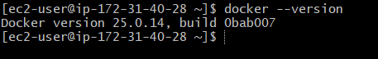

STEP 2: Create Docker Network
docker network create devops-network

STEP 3: Create Jenkins Container
Run Jenkins:
docker run -d \
--name jenkins \
--network devops-network \
-p 8080:8080 \
-p 50000:50000 \
-v jenkins_home:/var/jenkins_home \
-v /var/run/docker.sock:/var/run/docker.sock \
jenkins/jenkins:lts
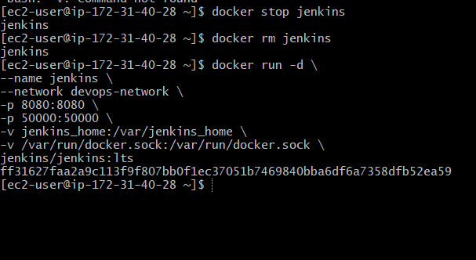
Check:
docker ps

STEP 4: Get Jenkins Password
docker exec jenkins cat /var/jenkins_home/secrets/initialAdminPassword
Copy password.
Open:
http://<EC2-PUBLIC-IP>:8080
Login.
Install suggested plugins.
Create admin user.
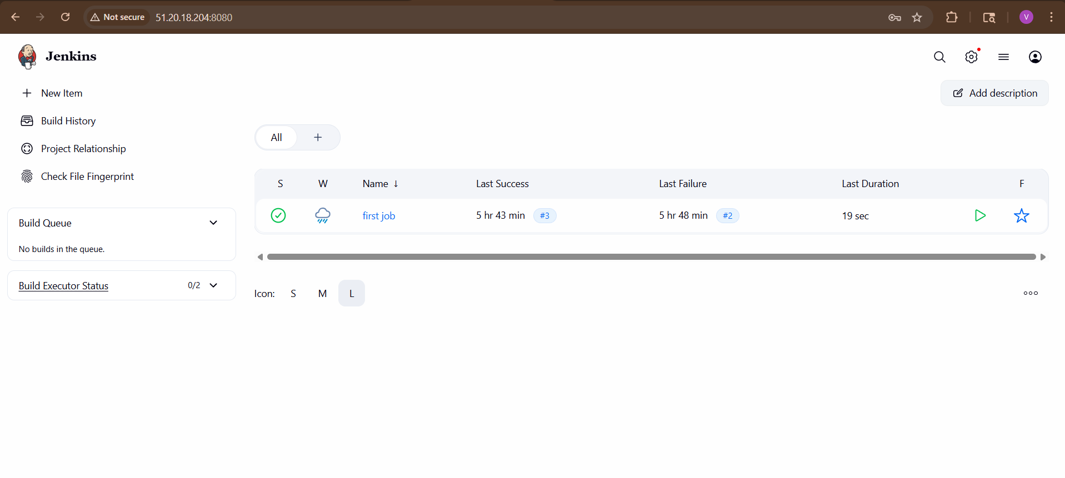

STEP 5: Install Maven + Docker Inside Jenkins
Enter Jenkins container:
docker exec -u 0 -it jenkins bash
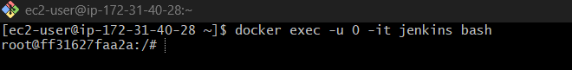
Update packages:
apt update
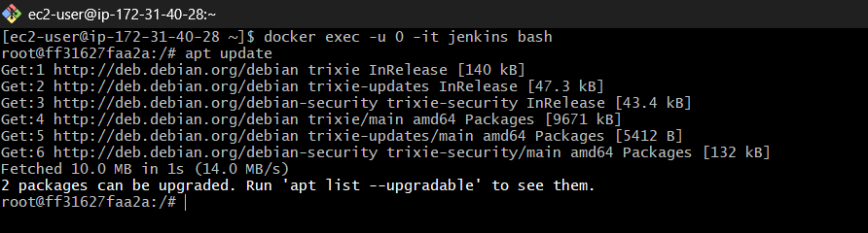

Install required tools:
apt install -y default-jdk maven docker.io git
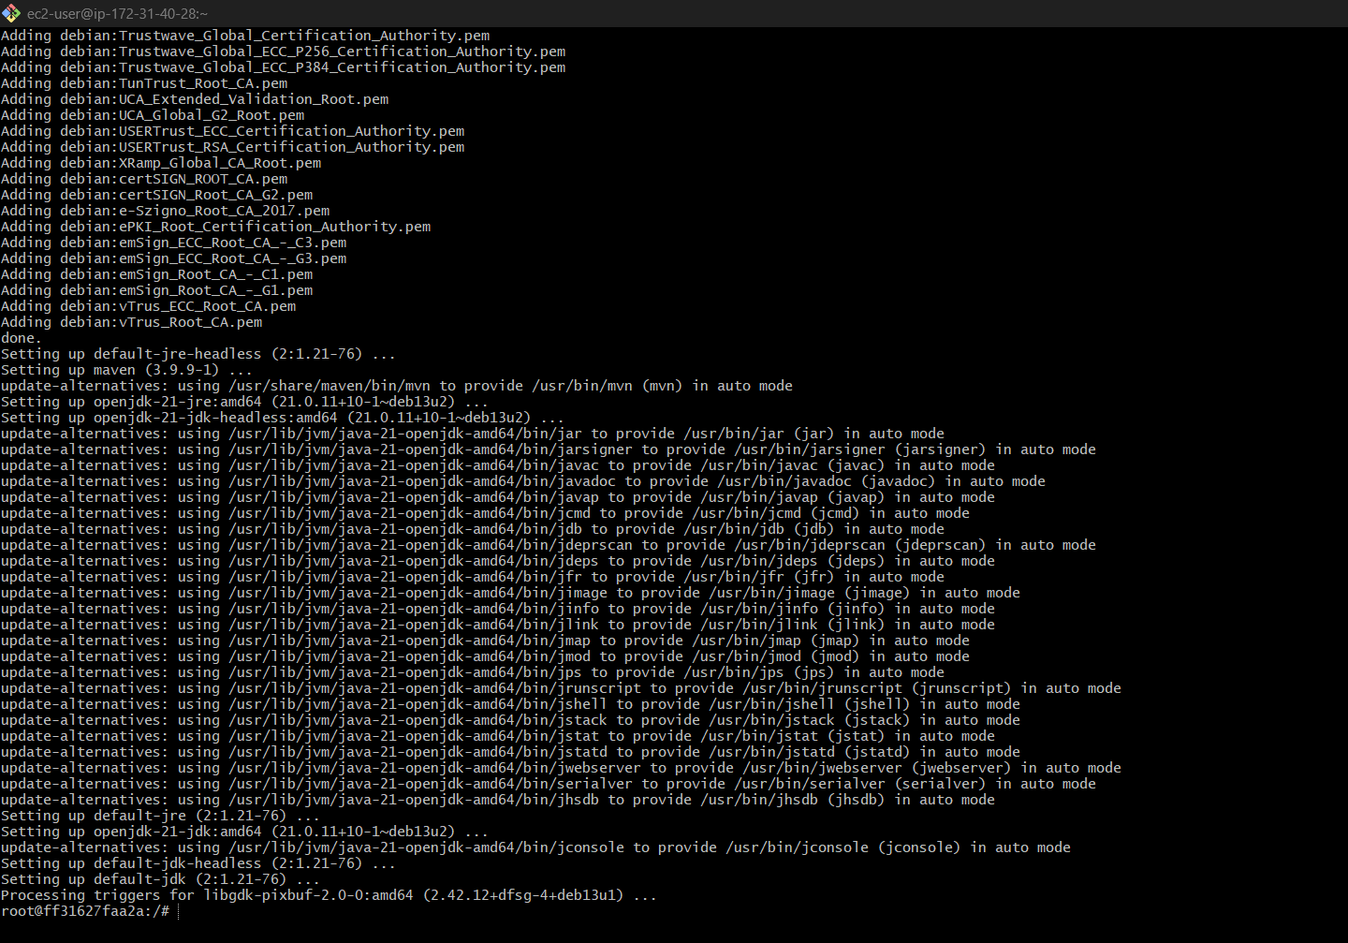

Verify:
mvn -version
docker --version
java -version
git --version
Exit:
Exit

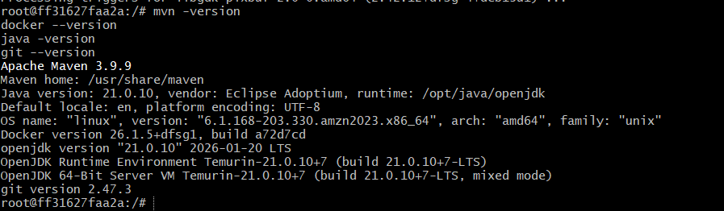

STEP 6: Configure Jenkins Tools
Go to:
Manage Jenkins → Tools

Configure JDK
Add JDK:
Field | Value
Name | jdk17
JAVA_HOME | /usr/lib/jvm/java-17-openjdk-amd64
Uncheck:
Install automatically
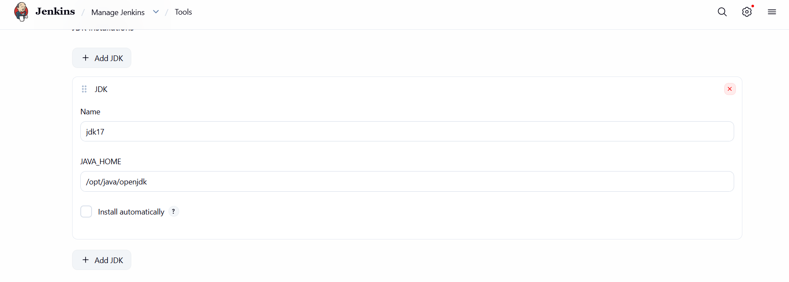

Configure Maven
Add Maven:
Field | Value
Name | maven3
MAVEN_HOME | /usr/share/maven
Uncheck:
Install automatically
Save.
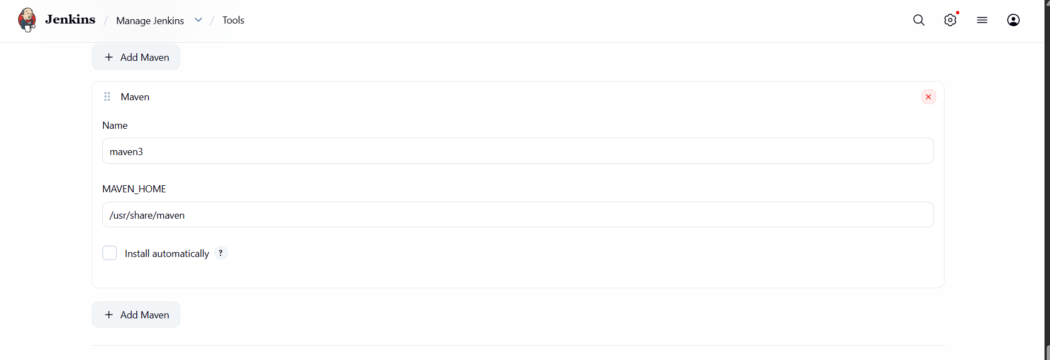

STEP 7: Prepare GitHub Repository
Your GitHub repo must contain:
pom.xml
src/
Dockerfile

STEP 1: Clone Repository In EC2
Go to EC2 terminal:
git clone https://github.com/betawins/hiring-app.git
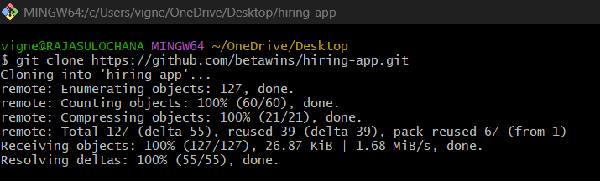
Move into repo:
cd hiring-app
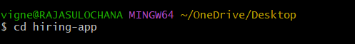
Check files:
Ls
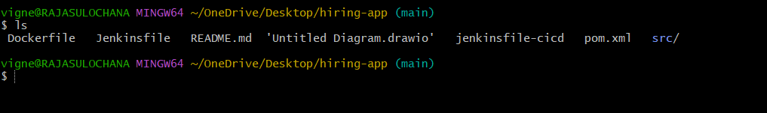
You should see:
- pom.xml
- src/

STEP 8: Create Dockerfile
STEP 2: Create Dockerfile
Run:
vi Dockerfile
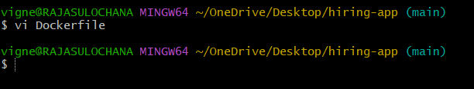
Press:
i
to enter insert mode.
Paste:
FROM tomcat:9
COPY target/*.war /usr/local/tomcat/webapps/
EXPOSE 8080
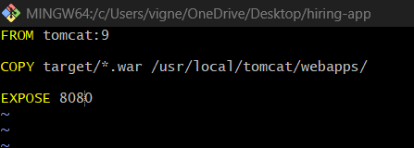

STEP 3: Save File
Press:
ESC
Then type:
:wq
Hit Enter.

STEP 4: Verify Dockerfile
Run:
cat Dockerfile
You should see:
FROM tomcat:9
COPY target/*.war /usr/local/tomcat/webapps/
EXPOSE 8080
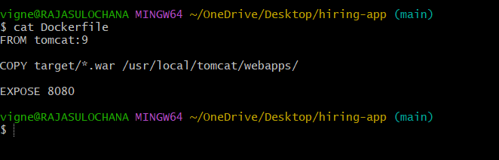

STEP 5: Push Dockerfile To GitHub
Check git status:
git status

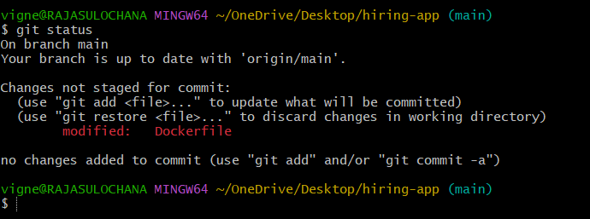
Add file:
git add Dockerfile
Commit:
git commit -m "Added Dockerfile"
Push:
git push origin main
OPTION 1 (Recommended) → Fork Repo
Open:
https://github.com/betawins/hiring-app
Click:
Fork
This creates:
https://github.com/vigneshadlagatta1/hiring-app
under your account.
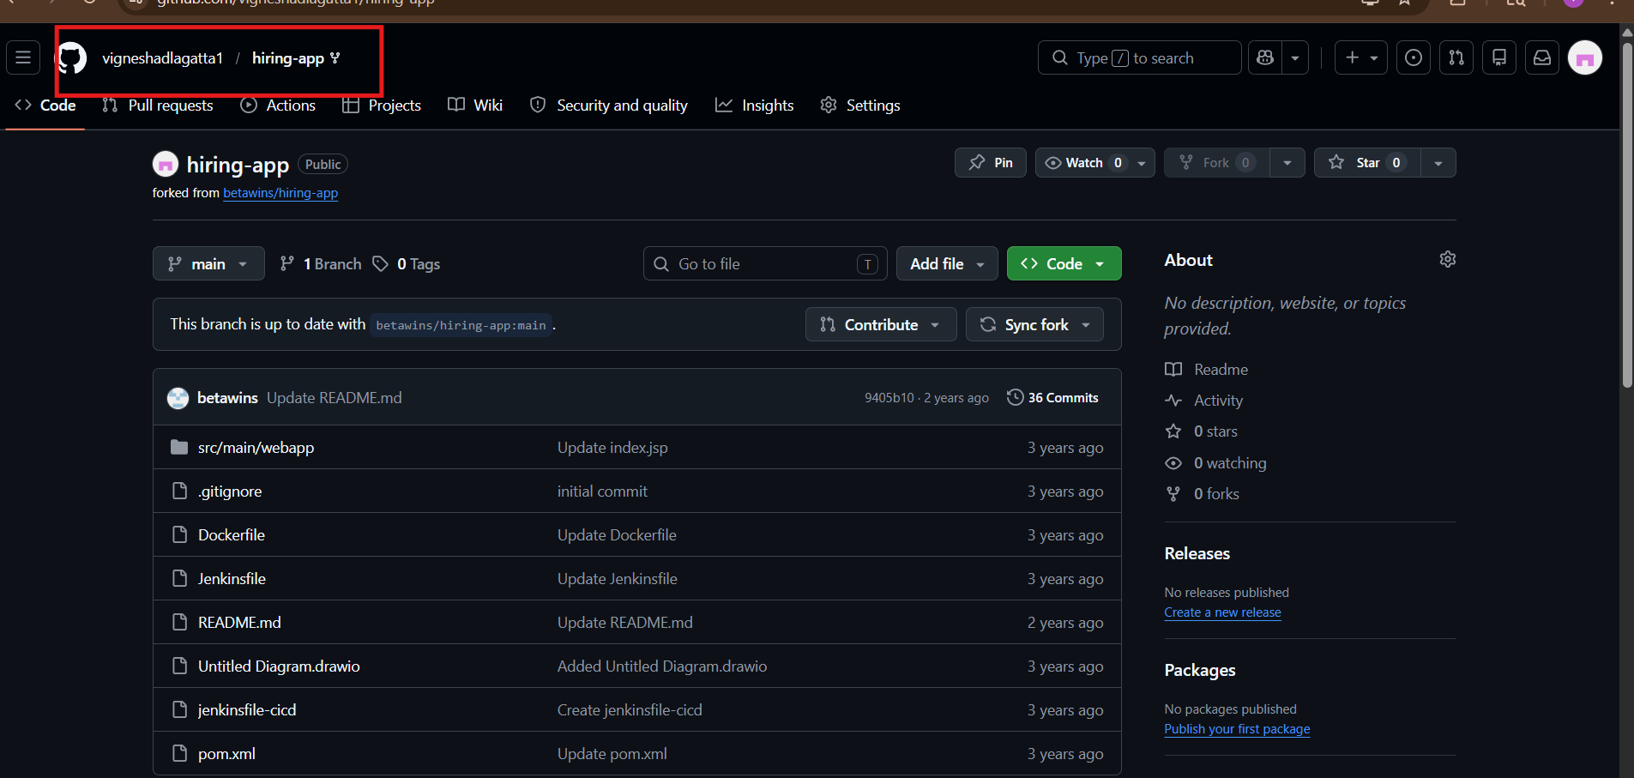

STEP 2: Change Git Remote
Inside project folder run:
git remote -v
Remove old remote:
git remote remove origin
Add your repo:
git remote add origin https://github.com/vigneshadlagatta1/hiring-app.git
Verify:
git remote -v

STEP 3: Push Code
Run:
git push -u origin main
GitHub may ask:
- username
- password/token
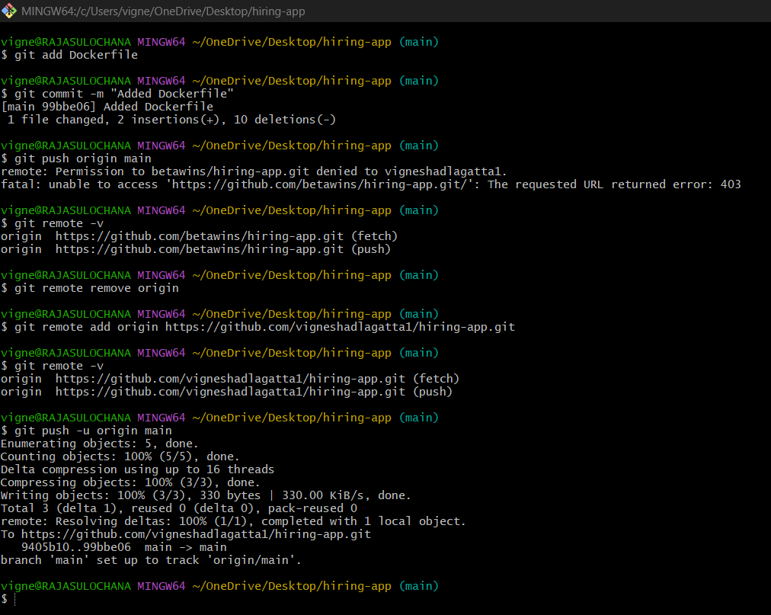

STEP 6: Verify In GitHub
Open repo:
https://github.com/betawins/hiring-app
You should now see:
Dockerfile
inside repo root directory.
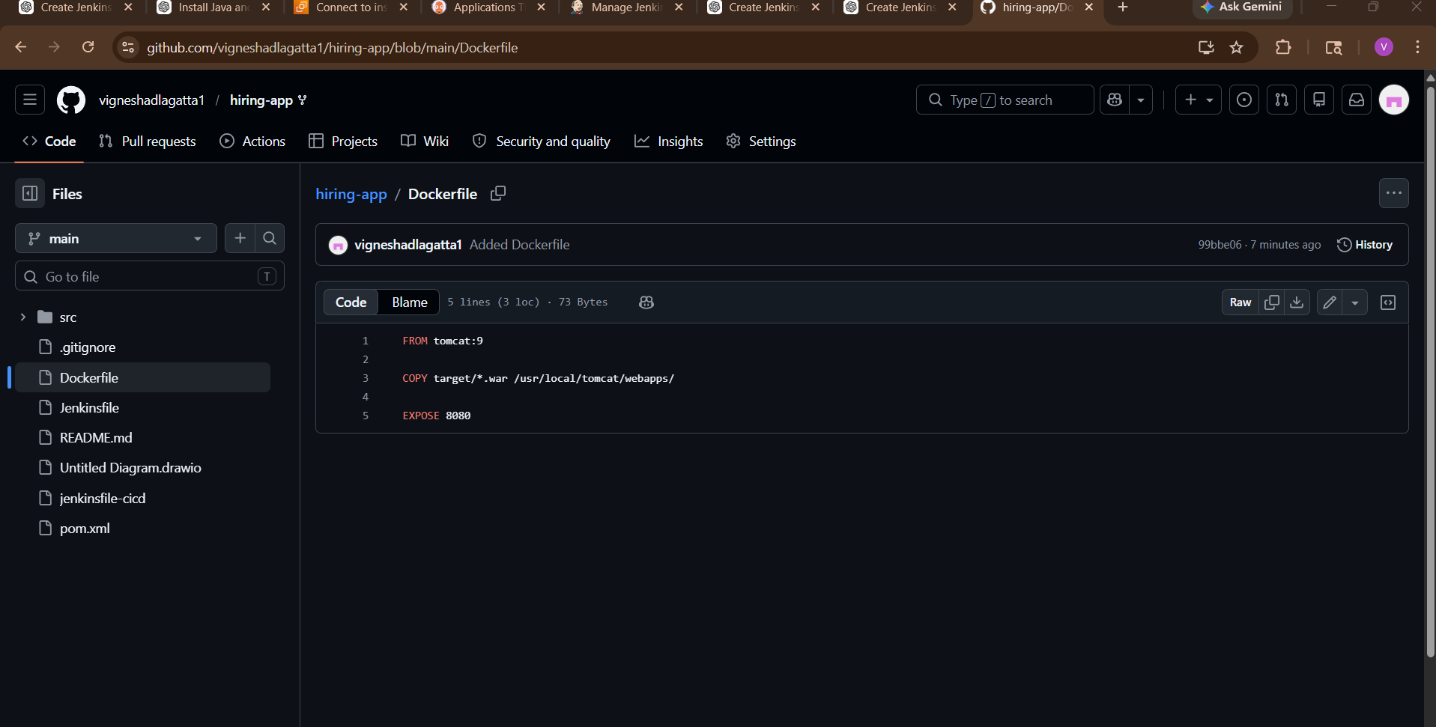

STEP 9: Create Jenkins Pipeline Job
Go to Jenkins dashboard.
Click:
New Item
Name:
docker-build-job
Select:
Pipeline
Click OK.
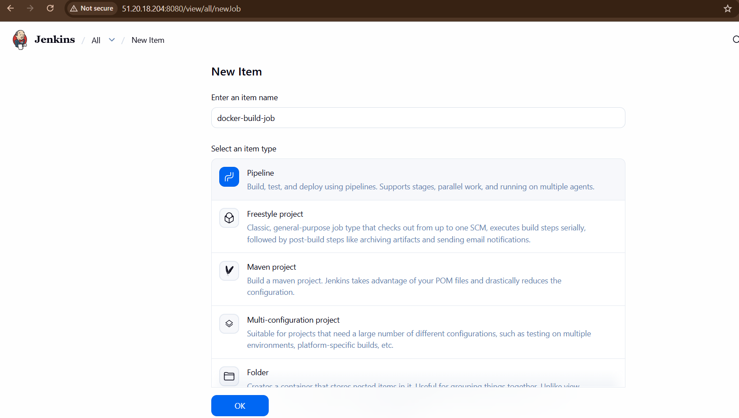

STEP 10: Add Pipeline Script
Go to:
Pipeline → Definition → Pipeline Script
Paste:
pipeline {
agent any
tools {
jdk 'jdk17'
maven 'maven3'
}
environment {
IMAGE_NAME = "hiring-app"
IMAGE_TAG = "v1"
}
stages {
stage('Git Clone') {
steps {
git branch: 'main',
url: 'https://github.com/vigneshadlagatta1/hiring-app.git'
}
}
stage('Maven Build') {
steps {
sh 'mvn clean package'
}
}
stage('Run Tests') {
steps {
sh 'mvn test'
}
}
stage('Build Docker Image') {
steps {
sh 'docker build -t $IMAGE_NAME:$IMAGE_TAG .'
}
}
stage('Verify Docker Image') {
steps {
sh 'docker images'
}
}
}
post {
success {
echo 'Docker Image Built Successfully'
}
failure {
echo 'Build Failed'
}
}
}
Save.

STEP 11: Build Job
Click:
Build Now

STEP 12: Check Console Output
Open:
Build History → Console Output
You should see:
BUILD SUCCESS
and:
Successfully tagged hiring-app:v1

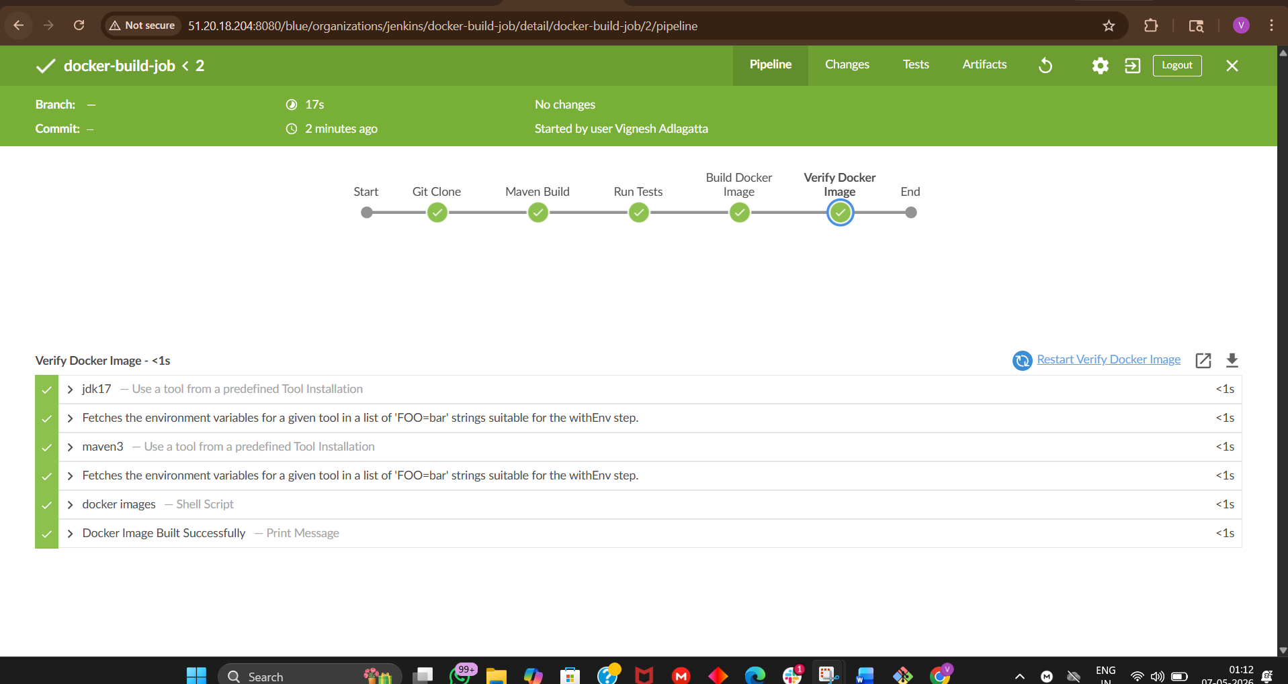
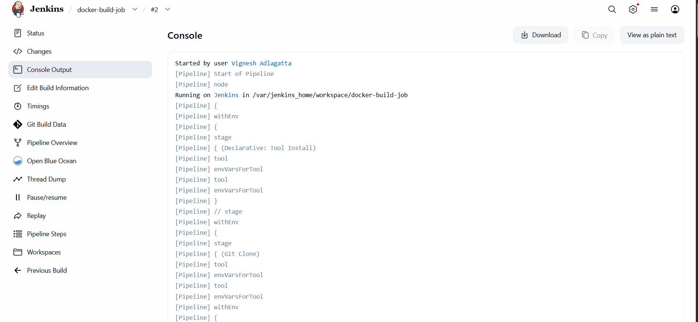
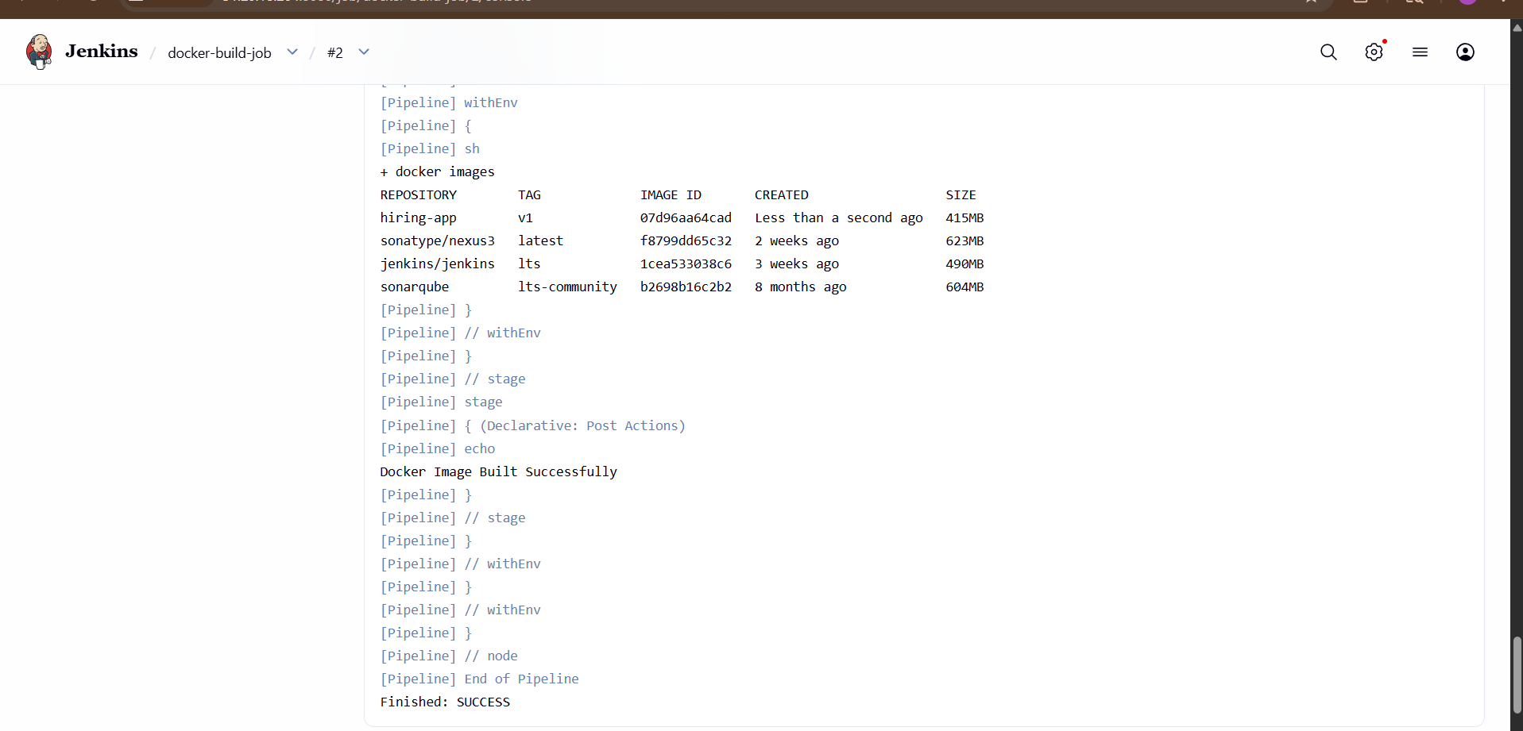
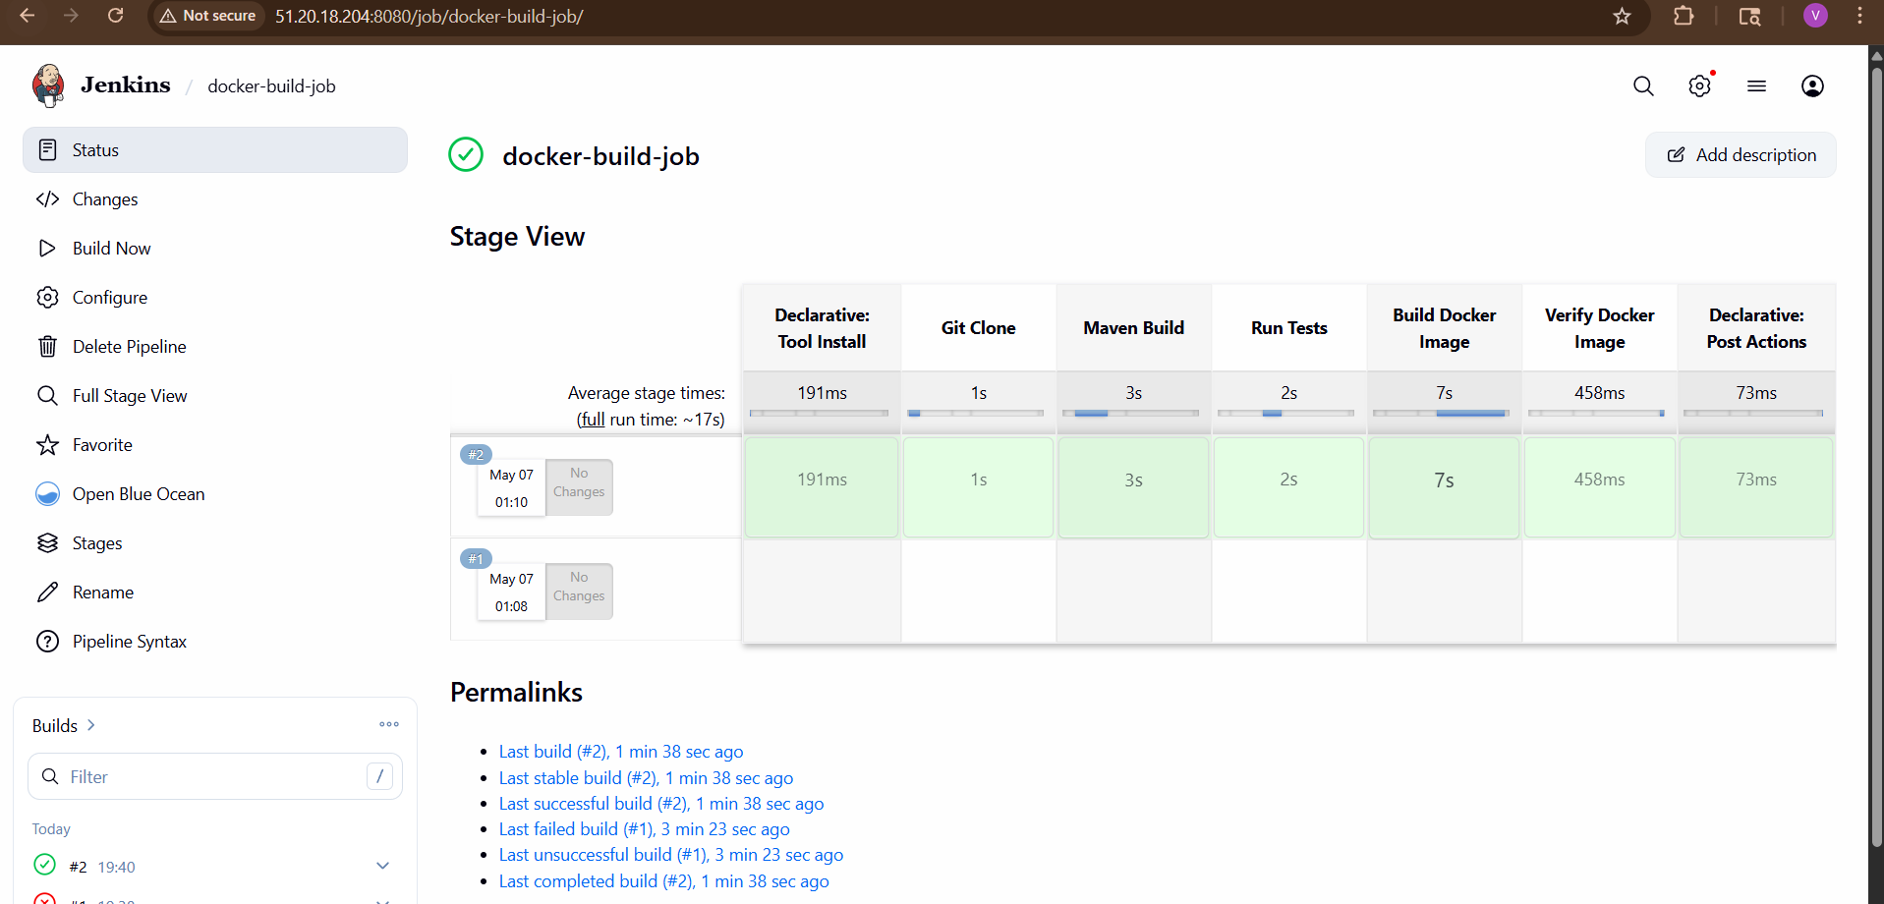

STEP 13: Verify Docker Image On EC2
Run:
docker images
You should see:
hiring-app v1
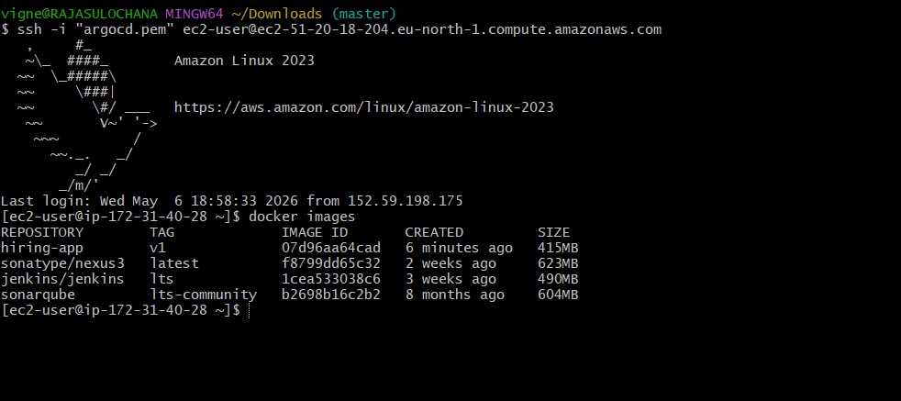

STEP 14: Run Docker Container
docker run -d \
--name hiring-container \
-p 8090:8080 \
hiring-app:v1
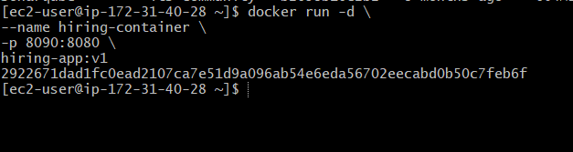
Verify:
docker ps
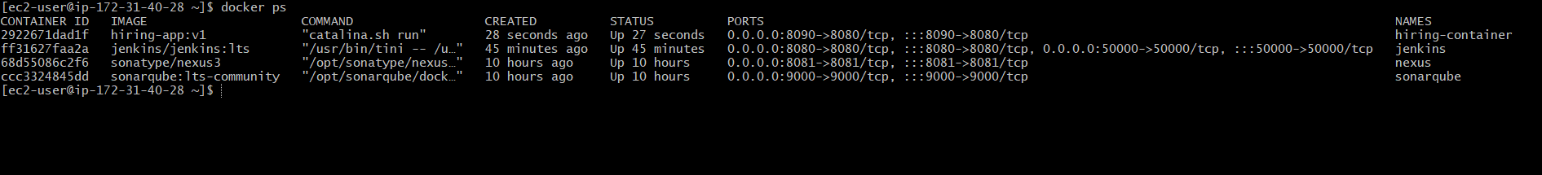

STEP 15: Access Application
Open browser:
http://<EC2-PUBLIC-IP>:8090
Example:
If WAR file is:
hiring.war
then app URL becomes:
http://51.20.18.204:8090/hiring
NOT:
http://51.20.18.204:8090
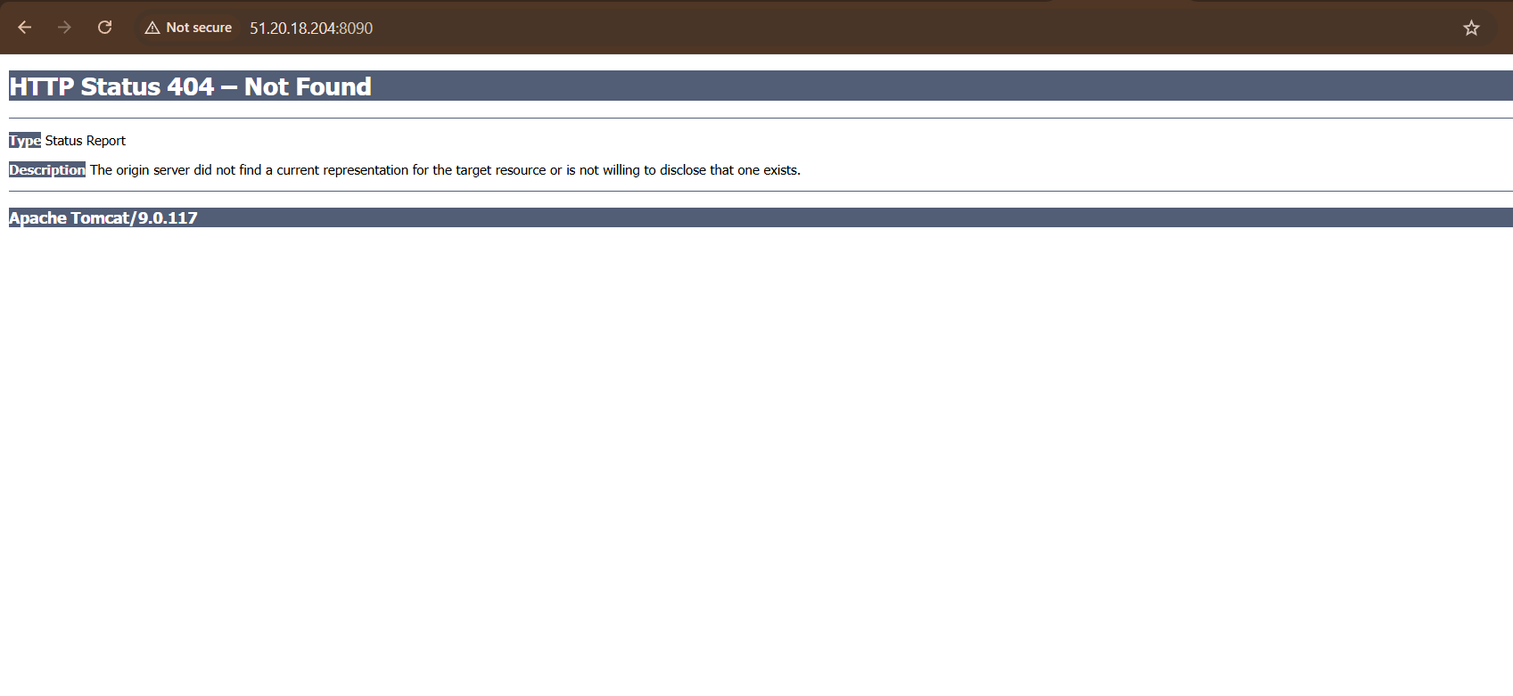
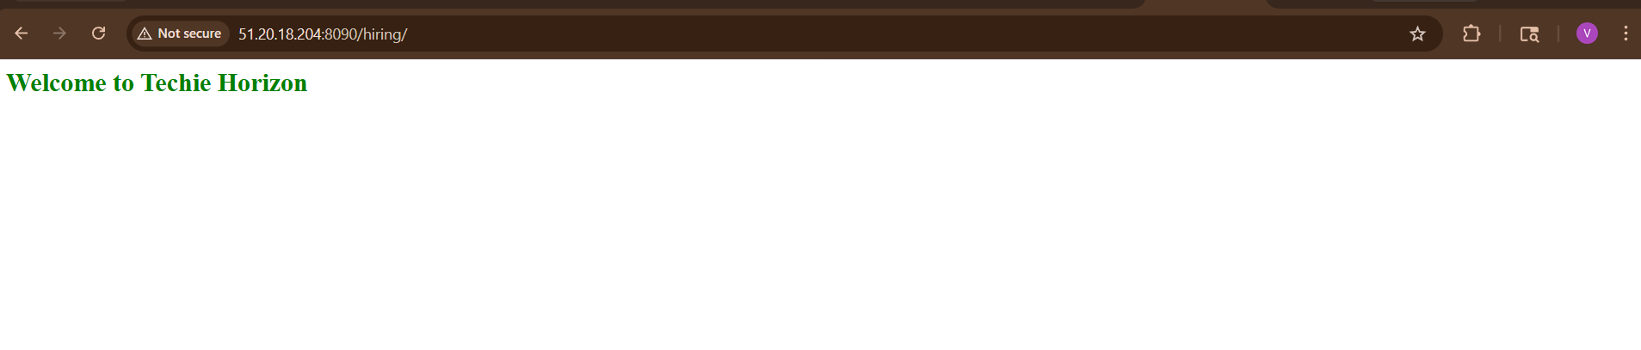
Your application should open 🎉

Full CI Docker Pipeline Completed
Final flow:
GitHub
↓
Jenkins
↓
Maven Build
↓
WAR File
↓
Docker Image
↓
Container Running

4 )Create ArgoCD job to deploy on ek8s cluster.
Now let’s build the next level:
Jenkins → DockerHub → ArgoCD → EKS
Goal:
GitHub
↓
Jenkins CI
↓
Docker Image
↓
DockerHub
↓
Kubernetes Manifest Repo
↓
ArgoCD
↓
EKS Cluster Deployment

STEP 1: Verify EKS Cluster Access
On EC2:
kubectl get nodes
You should see worker nodes.
If not configured:
aws configure
Then:
aws eks update-kubeconfig \
--region eu-north-1 \
--name demo-cluster
Verify:
kubectl get nodes

STEP 2: Install ArgoCD In EKS
Create namespace:
kubectl create namespace argocd
Install ArgoCD:
kubectl apply -n argocd -f https://raw.githubusercontent.com/argoproj/argo-cd/stable/manifests/install.yaml
Wait 2 minutes.
Check pods:
kubectl get pods -n argocd
All should become:
Running

STEP 3: Expose ArgoCD Server
Run:
kubectl patch svc argocd-server -n argocd \
-p '{"spec": {"type": "LoadBalancer"}}'
Check external IP:
kubectl get svc -n argocd
Look for:
argocd-server
Copy EXTERNAL-IP.

STEP 4: Get ArgoCD Password
Run:
kubectl get secret argocd-initial-admin-secret -n argocd \
-o jsonpath="{.data.password}" | base64 -d
Username:
admin
Password:
(output from above command)

STEP 5: Open ArgoCD UI
Browser:
https://<ARGOCD-EXTERNAL-IP>
Login:
- Username → admin
- Password → copied password

STEP 1: Create New GitHub Repository
Open GitHub:
GitHub New Repository
Create repo:
Field | Value
Repository Name | hiring-k8s-manifests
Visibility | Public
Initialize README | ✅
Click:
Create repository
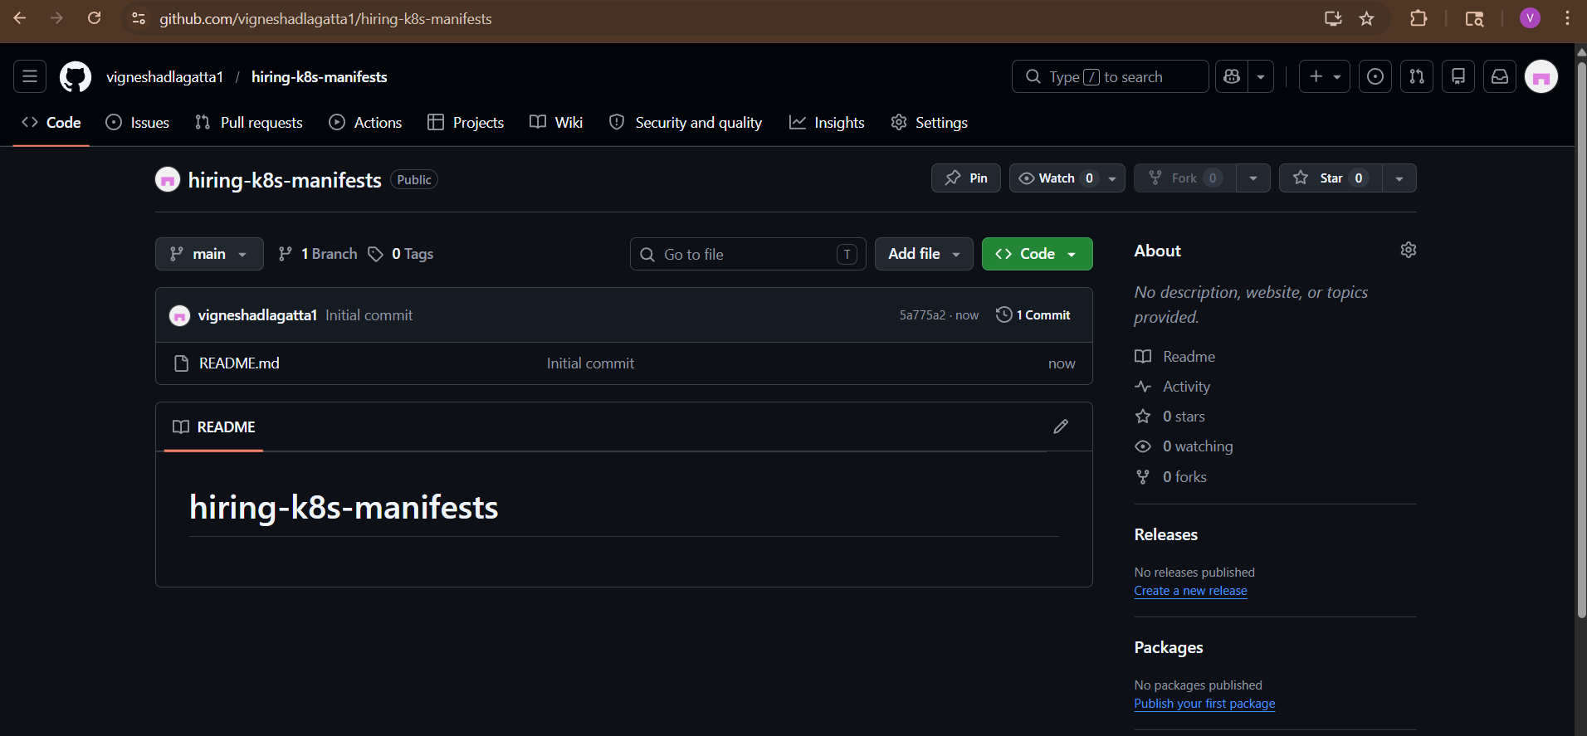

STEP 2: Clone Repository To Local System
Open Git Bash / terminal:
git clone https://github.com/vigneshadlagatta1/hiring-k8s-manifests.git
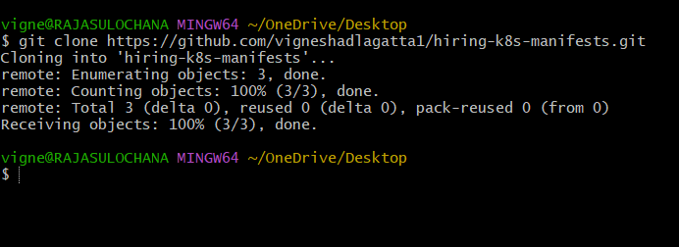
Move into repo:
cd hiring-k8s-manifests
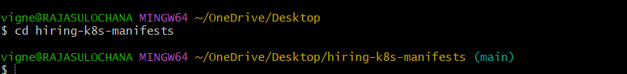
Check:
ls
You should see:
README.md
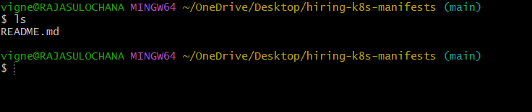

STEP 3: Create deployment.yaml
Run:
vi deployment.yaml
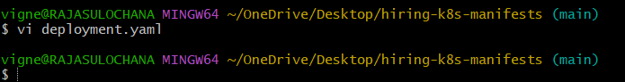
Press:
i
Paste:
apiVersion: apps/v1
kind: Deployment
metadata:
name: hiring-app
namespace: default
spec:
replicas: 2
selector:
matchLabels:
app: hiring-app
template:
metadata:
labels:
app: hiring-app
spec:
containers:
- name: hiring-app
image: vigneshadlagatta7/hiring-app:v1
ports:
- containerPort: 8080
Save file:
Press:
ESC
Then type:
:wq
Hit Enter.
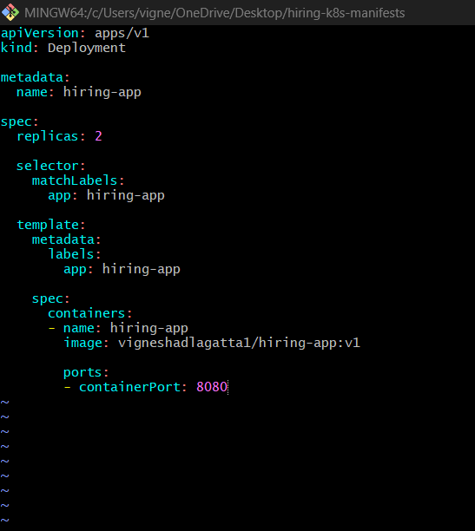

STEP 4: Create service.yaml
Run:
vi service.yaml
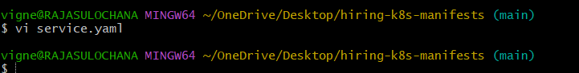

Press:
i
Paste:
apiVersion: v1
kind: Service
metadata:
name: hiring-service
namespace: default
spec:
type: LoadBalancer
selector:
app: hiring-app
ports:
- port: 80
targetPort: 8080

Save:
ESC
:wq
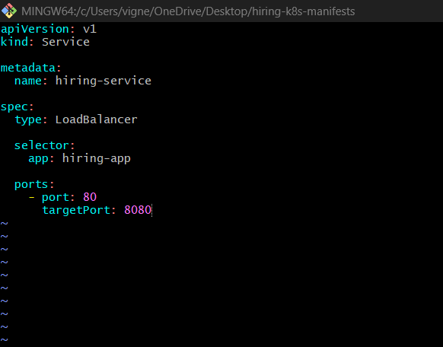

STEP 5: Verify Files
Run:
ls
You should see:
README.md
deployment.yaml
service.yaml
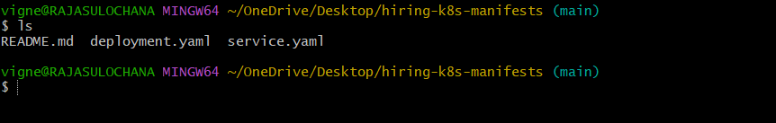
Check contents:
cat deployment.yaml
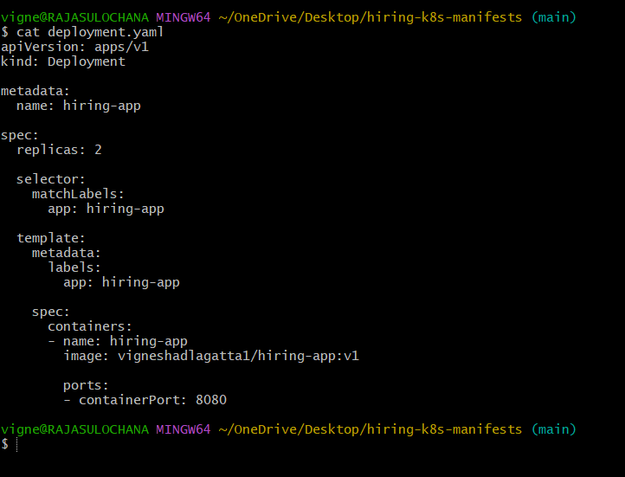
cat service.yaml
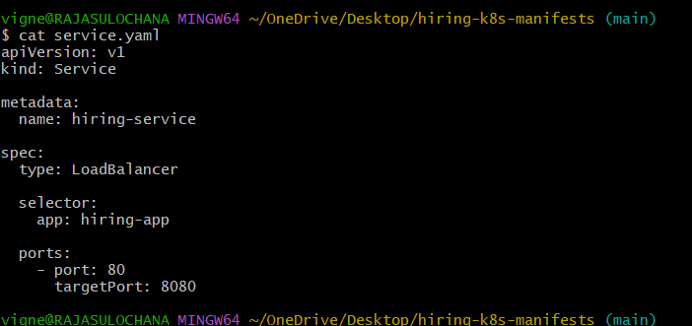

STEP 6: Add Files To Git
Run:
git status
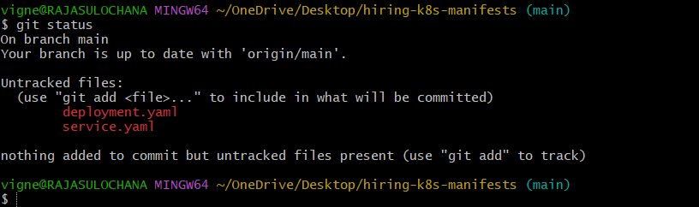
Add files:
git add .
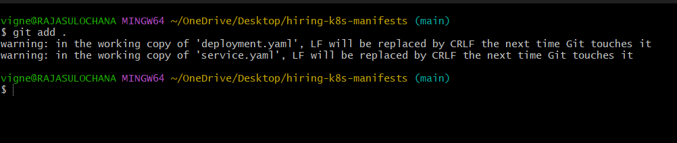
Commit:
git commit -m "Added Kubernetes manifests"
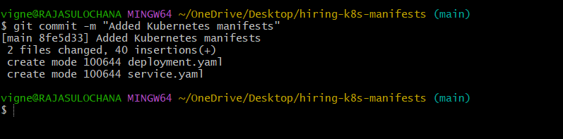

STEP 7: Push To GitHub
Run:
git push origin main
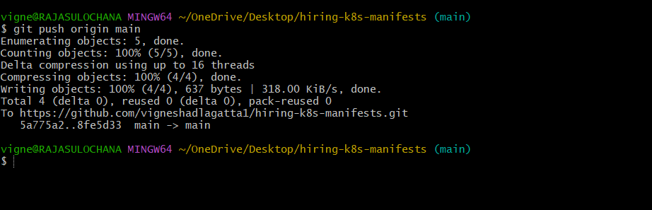

STEP 8: Verify In GitHub
Open repo:
hiring-k8s-manifests Repository
You should now see:
deployment.yaml
service.yaml
inside repository
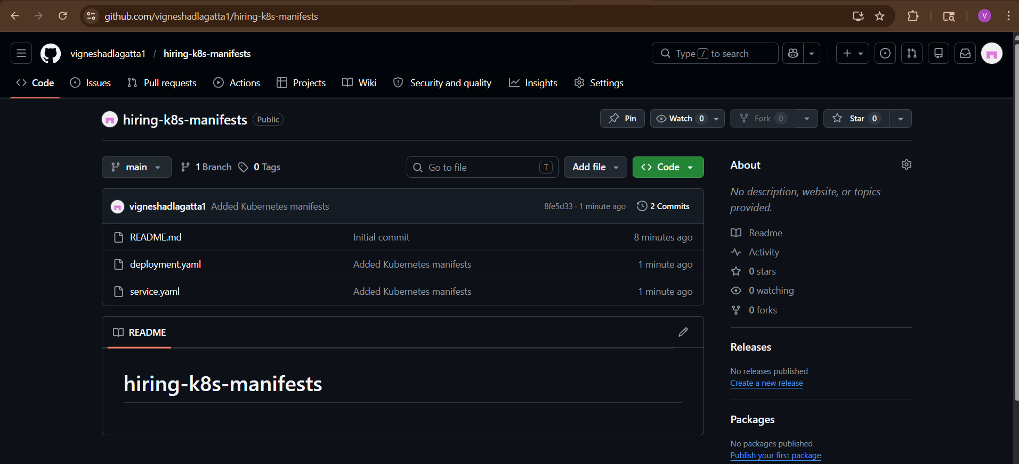
STEP 7: Push Docker Image To DockerHub
Login:
docker login
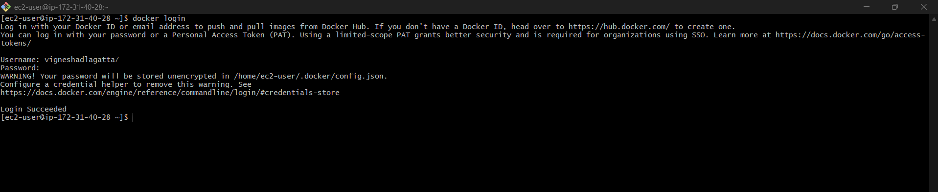
Tag image:
docker tag hiring-app:v1 vigneshadlagatta1/hiring-app:v1
Verify:
docker images
You should now see:
vigneshadlagatta7/hiring-app
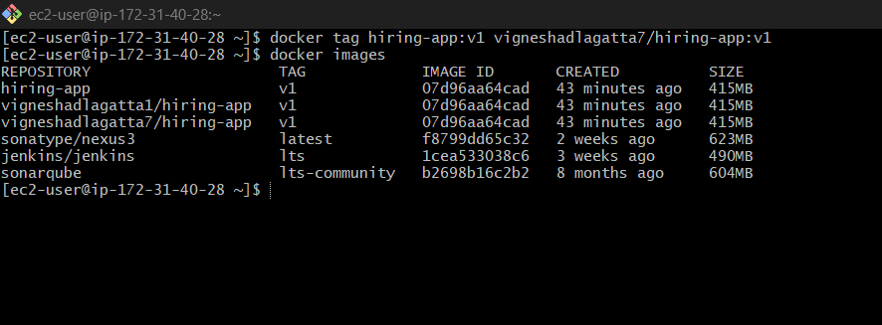
STEP 2: Create DockerHub Repository
Open:
Docker Hub Repositories
Create repository:
Field | Value
Repository Name | hiring-app
Visibility | Public
under account:
vigneshadlagatta7

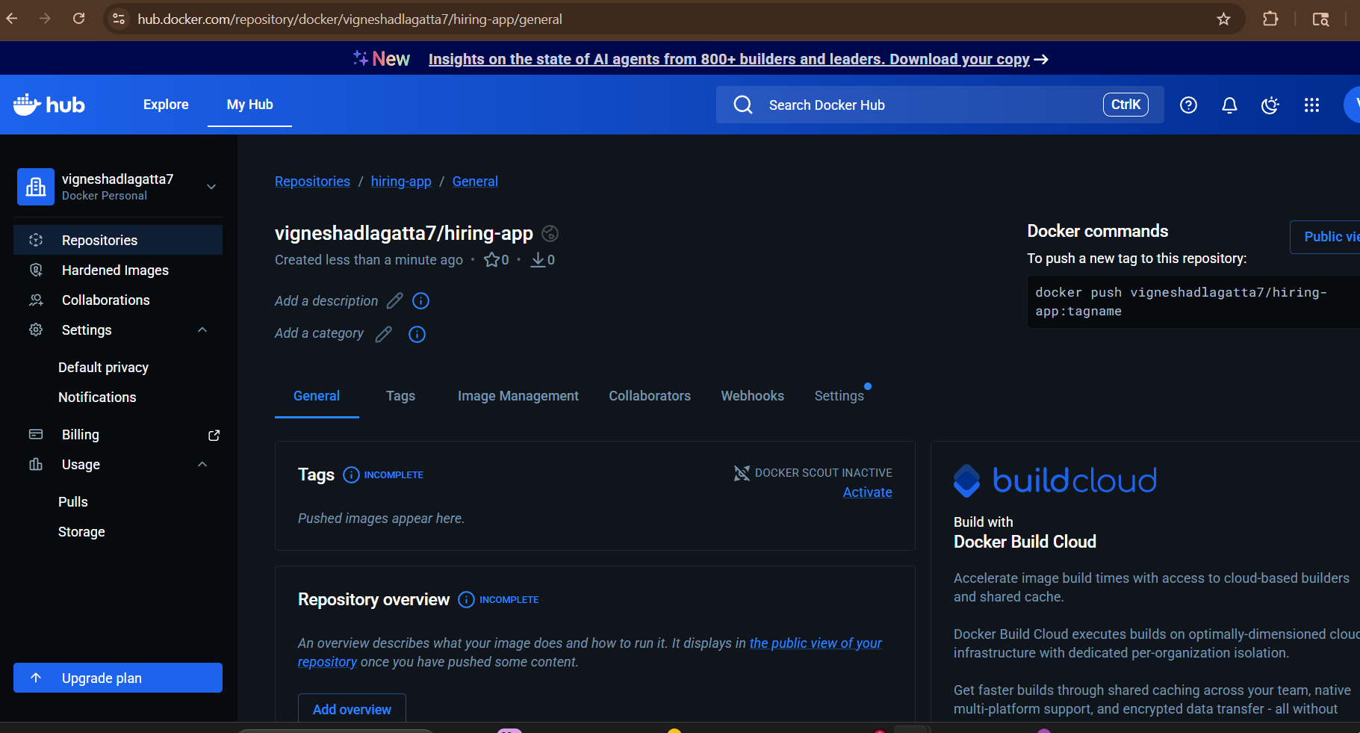

STEP 3: Push Image
Run:
docker push vigneshadlagatta7/hiring-app:v1
This should work successfully

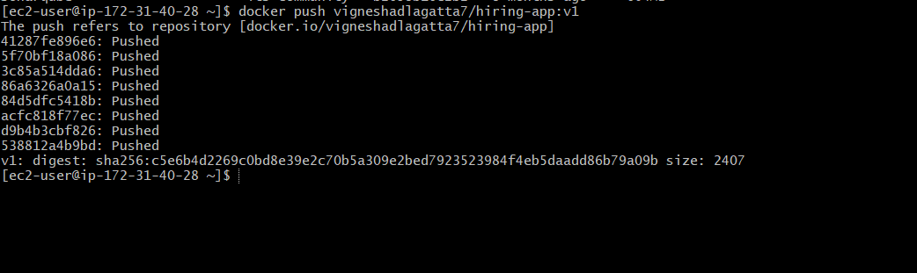

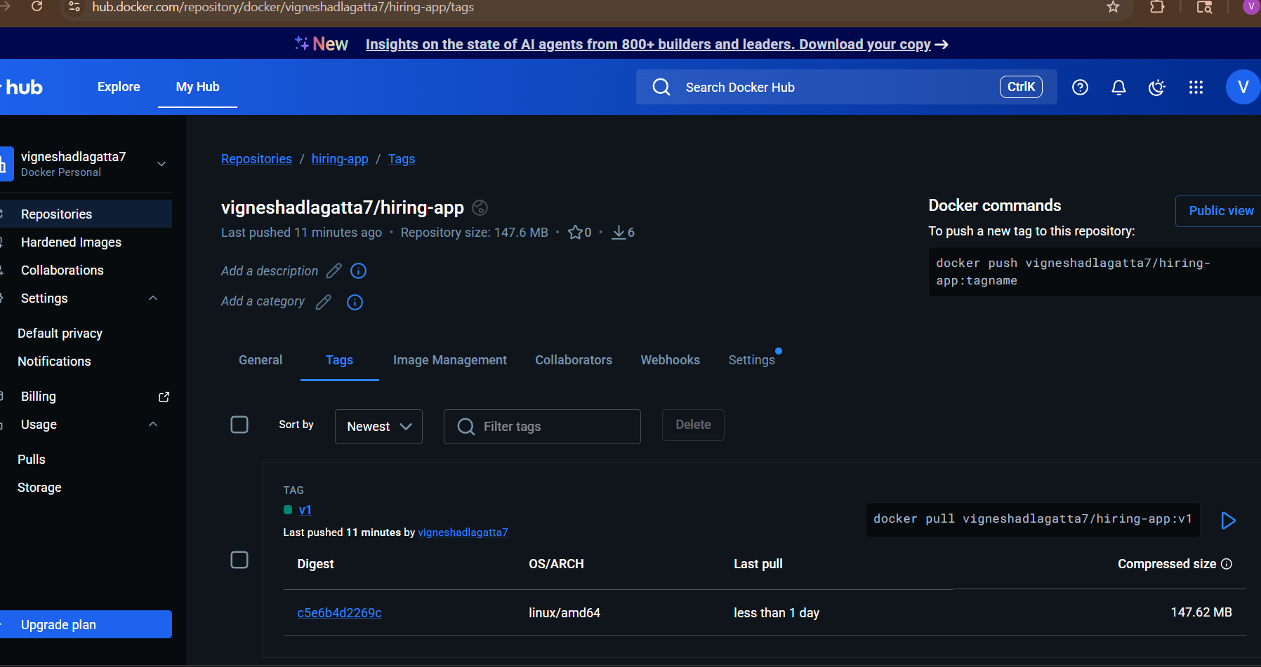

STEP 8: Create ArgoCD Application
In ArgoCD UI:
Click:
NEW APP
Fill:
Field | Value
Application Name | hiring-app
Project | default
Sync Policy | Automatic
Repository URL | your manifest repo URL
Revision | HEAD
Path | .
Cluster URL | https://kubernetes.default.svc
Namespace | default
Click:
Create

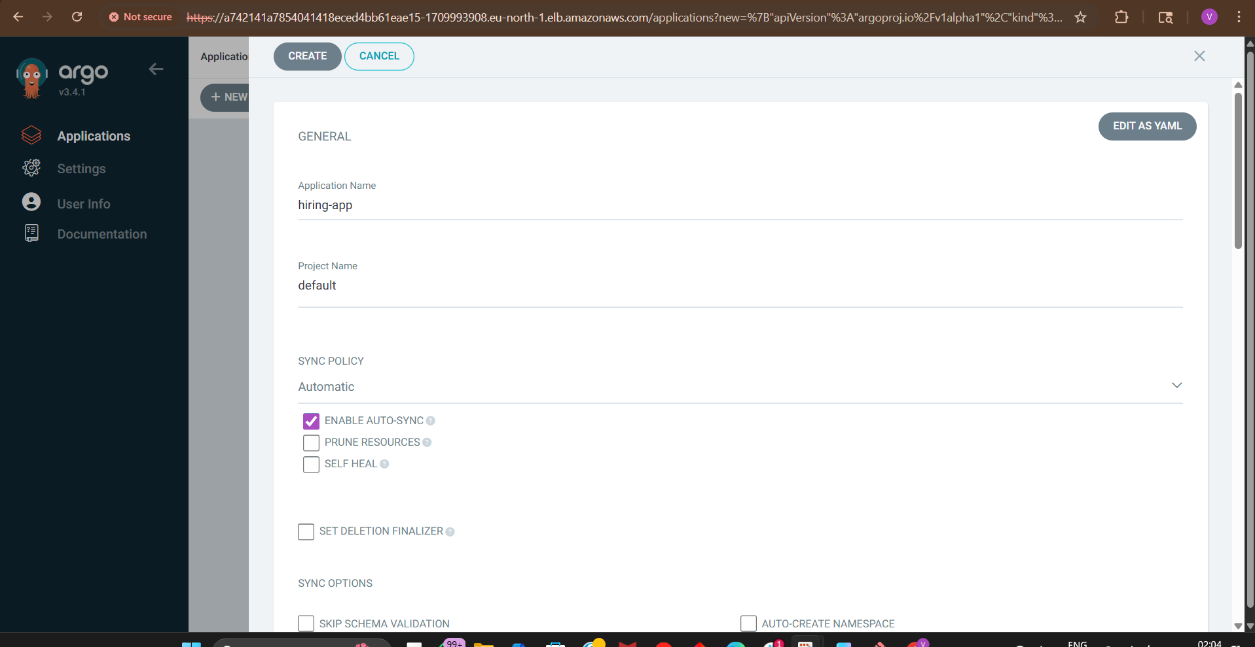
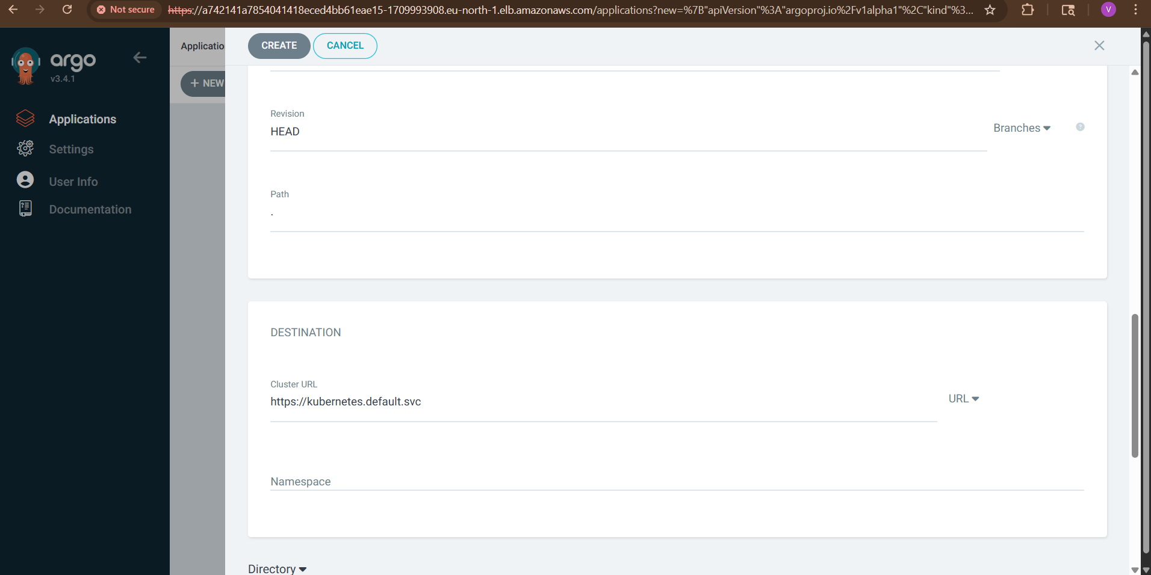
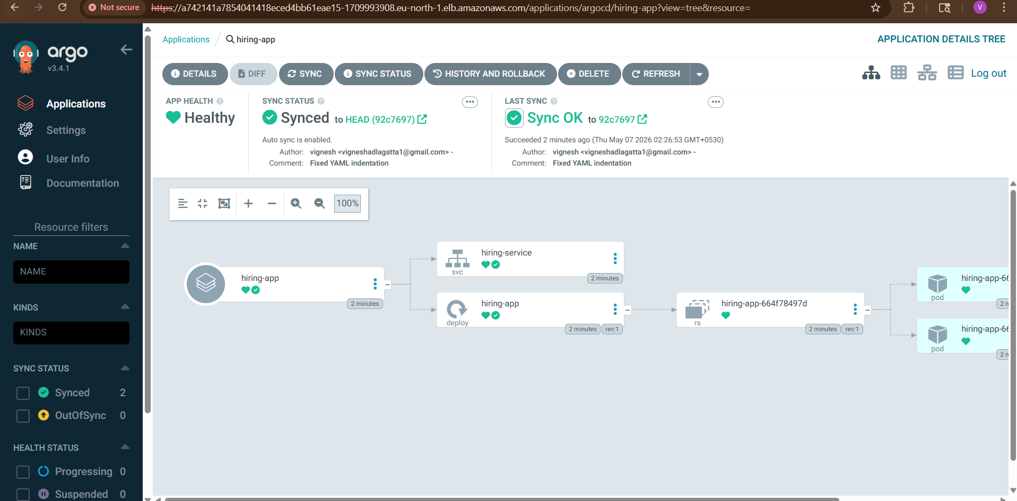
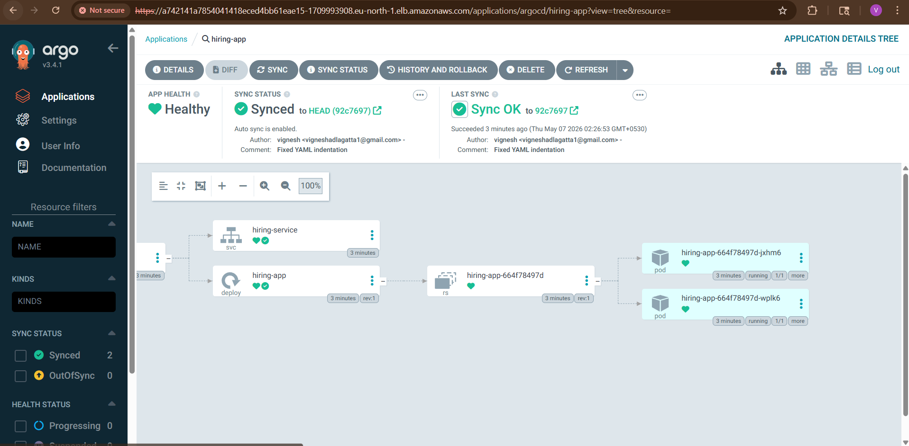

STEP 9: ArgoCD Deploys Automatically
ArgoCD now:
- pulls manifests from GitHub
- deploys to EKS
- monitors drift
- auto-syncs changes

STEP 10: Verify Deployment
Run:
kubectl get pods
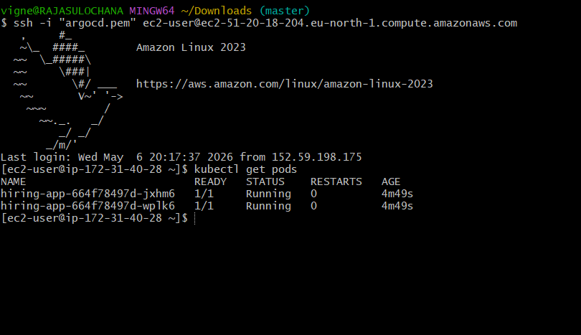

kubectl get svc
You’ll see:
hiring-service
Copy EXTERNAL-IP.

a113153158cc24a01ada09e04e342b4e-643465770.eu-north-1.elb.amazonaws.com

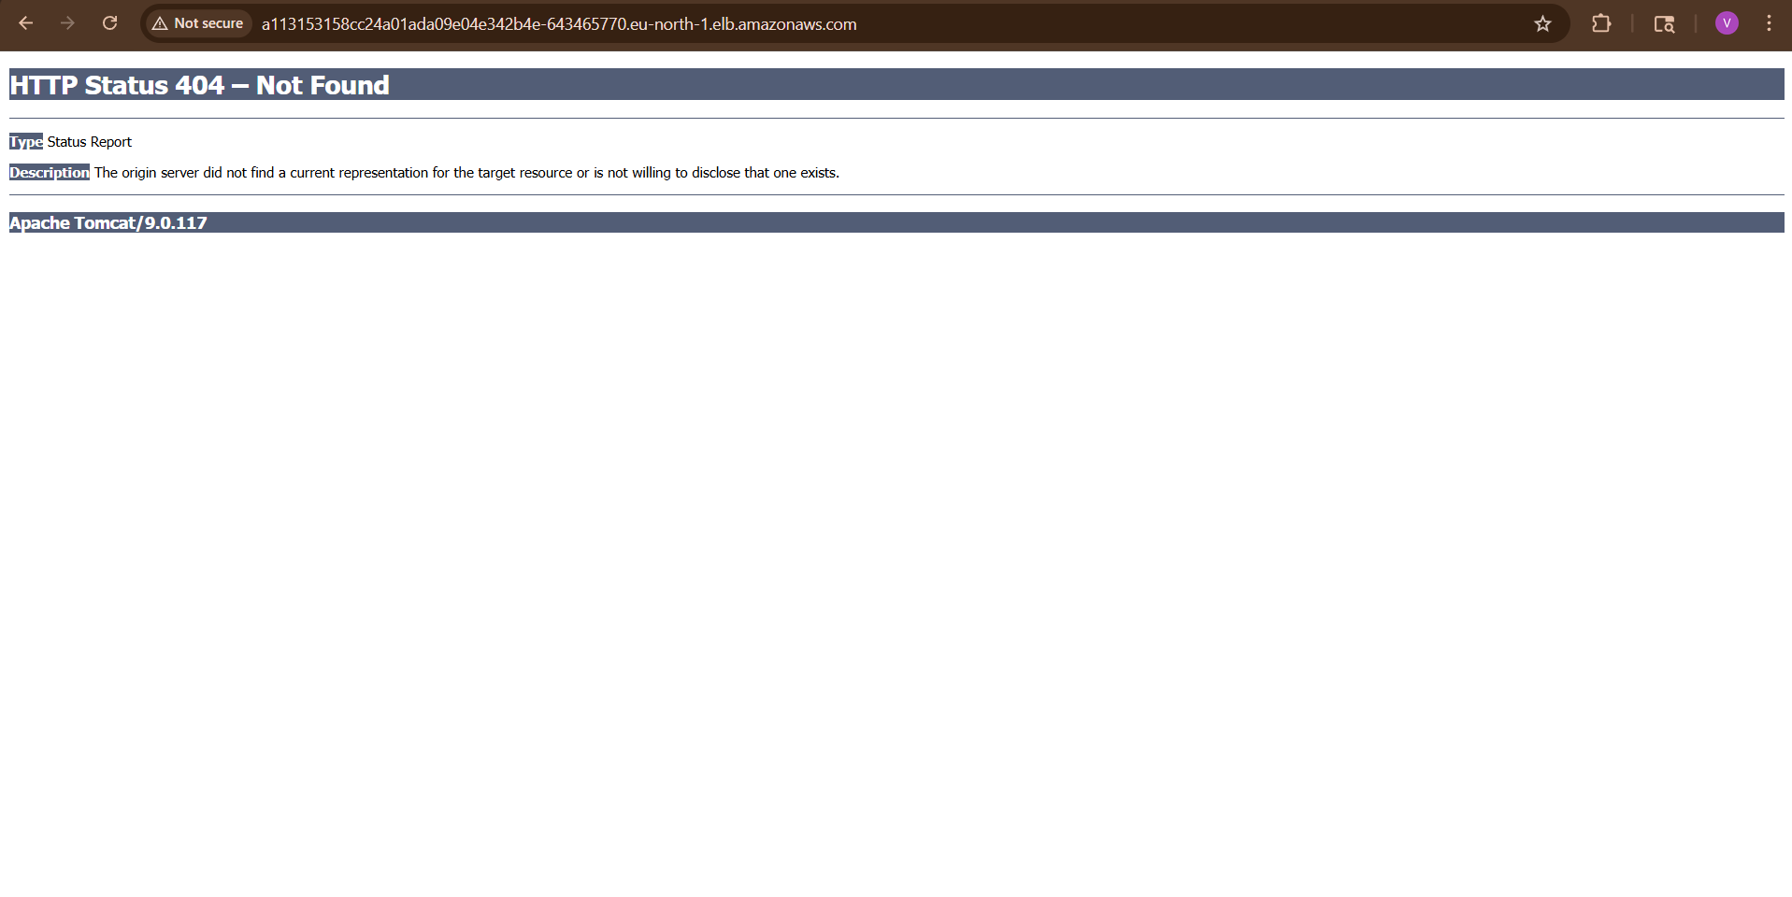
http://a113153158cc24a01ada09e04e342b4e-643465770.eu-north-1.elb.amazonaws.com/hiring/
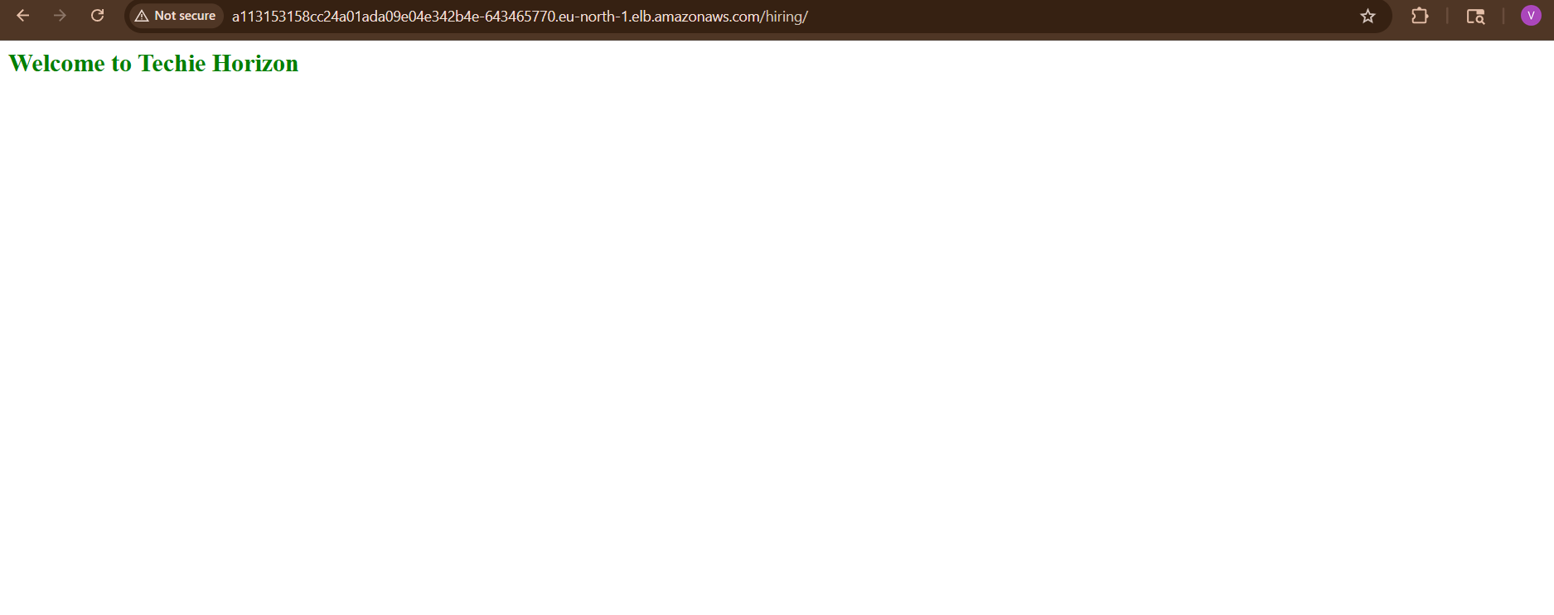

STEP 11: Open Application
Browser:
http://<LOADBALANCER-IP>
App deployed on EKS using ArgoCD.

Final GitOps Flow
Developer Pushes Code
↓
Jenkins Builds Docker Image
↓
Push To DockerHub
↓
Manifest Repo Updated
↓
ArgoCD Detects Change
↓
Deploys To EKS

Everything in cluster
kubectl get all

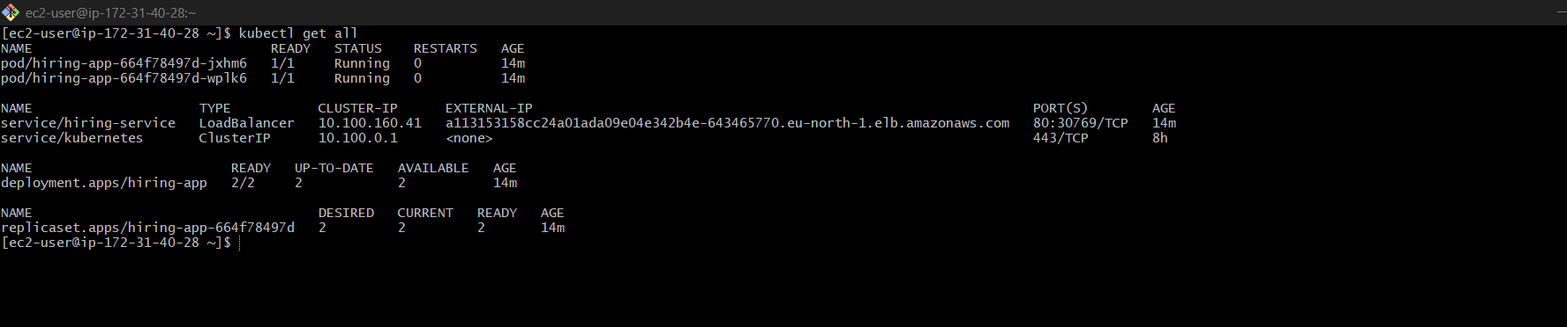

Everything all namespaces
kubectl get all -A

